`sd
Applications of Proportions
Standard: SWABAT interpret parts of an expression, such as terms, factors, and coefficients. (MCC912.A.SSE.1a)

Name: ___________________________________ Mr. Murphey’s Coordinate Algebra
Date: 1/13/2014 Block: 1 4


Inbox Task - Complete 1-4

- $\frac{4}{7}=\frac{8}{x}$

- $\frac{10}{10}=\frac{x}{2}$
- $\frac{11}{x}=\frac{33}{6}$

- $\frac{1}{4}=\frac{8}{x-3}$

College Name __________________ Average GPA ________ Average SAT __________
Applications of Proportions Find the value of x in each diagram.
1. ΔABC ∼ ΔDEF 2. FGHJK ∼ MNPQR
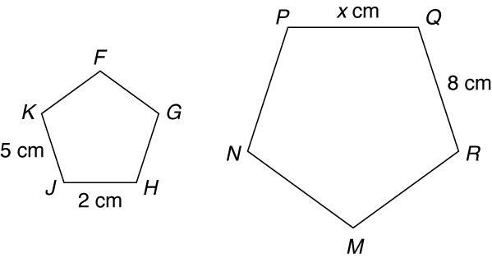
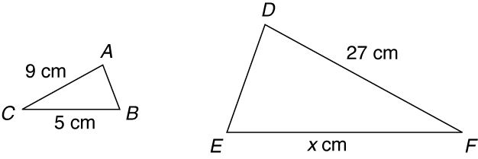

3. A utility worker is 5.5 feet tall and is casting a shadow
4 feet long. At the same time, a nearby utility pole casts
a shadow 20 feet long. Write and solve a proportion to
find the height of the utility pole. _____________________________________

Find the value of x in each diagram.
4. ΔACD ~ ΔABE 5. ΔQRV ~ ΔTRS
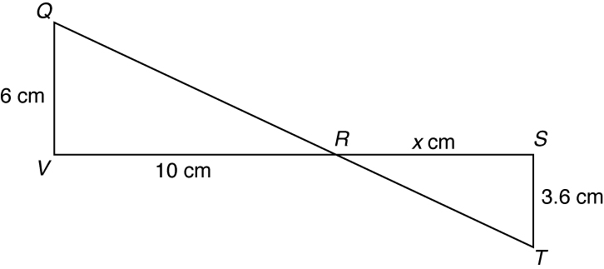
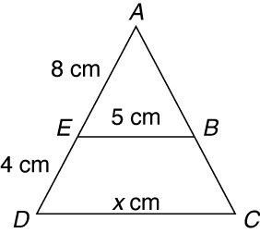

6. Keshawn is 5 ft 6 in. tall and casts a shadow that is one-fourth his height. At the same time,
a nearby tree casts a shadow that is twice Keshawn’s height. Write and solve a proportion
to find the height of the tree. _____________________________________

7. A cylinder has a radius of 3 cm and a length of 10 cm. Every dimension of the cylinder is multiplied by 3 to form a new cylinder. How is the ratio of the volumes related to
the ratio of corresponding dimensions?
8. A rectangle has an area of 48 in². Every dimension of the rectangle is multiplied by a scale factor, and the
new rectangle has an area of 12 in². What was the scale factor? _____________________________________

9. A triangle has an area of 20 in². Every dimension of the triangle is multiplied by a scale factor, and the new triangle has an area of 180 in². What was the scale factor?
_____________________________________

10. A rectangular prism has a volume of 112 cm³. Every dimension of the rectangular prism is
multiplied by a scale factor and the new volume is 1.75 cm³. What was the scale factor? _____________________________________
Write the correct answer.

1. A 4 by 5 inch photo is enlarged by multiplying every dimension by 2 to
form a similar 8 by 10 inch photo. What
is the ratio of the perimeter of the
smaller rectangle to that of the larger? What is the ratio of the two areas?

3. The Taylors plan to expand their
80 square foot garage by tripling the dimensions. What will be the area of
the new garage?

2. Pamela wants to buy a suitcase whose dimensions are 1$\frac{1}{2}$ times those of her
28 × 16 × 8 inch suitcase. How is the
ratio of the volumes related to the ratio
of corresponding dimensions? What is the ratio of the volumes?

4. A tent has a volume of 26.25 in³. Every dimension is multiplied by a scale factor so that the new tent has a volume of 1680 in³. What was the scale factor?

Complete the table below and use it to answer questions 5–8. Select the best answer. Assume the shadow lengths were measured at the same time of day.
Object | Length of Shadow (ft) | Height (ft)
Flagpole | 8 | 20
Oak tree | 12
Goal post | 18
Telephone pole |  | 17.5
Fence |  | 6.5

5. The flagpole casts an 8 foot shadow, as
shown in the table. At the same time,
the oak tree casts a 12 foot shadow.
How tall is the oak tree?
A 4.8 ft C 30 ft
B 24 ft D 32 ft
6. How tall is the goal post?
F 7.2 ft H 38 ft
G 30 ft J 45 ft

7. What is the length of the telephone
pole’s shadow?
A 5.5 ft C 25.5 ft
B 7 ft D 43.8 ft
8. What is the length of the fence’s
shadow?
F 1.5 ft H 16.25 ft
G 2.6 ft J 21.5 ft

