Name: ___________________________________ Mr. Murphey’s Analytical Geometry
Date: 1/13/2014 Block: 2
Standard: SWABAT interpret parts of an expression, such as terms, factors, and coefficients. (MCC912.A.SSE.1a)

Conditional Statements


Inbox Task – Make a conjecture about each pattern. Write the next two items.
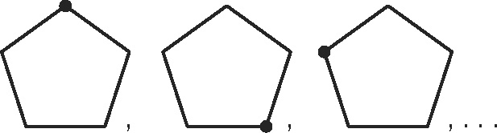
1. 1, 2, 2, 4, 8, 32, . . . 2.

College Name __________________ Average GPA ________ Average SAT __________
Conditional Statements
Match the correct term to complete each sentence.
A. hypothesis
B. converse
C. conclusion
D. if; then
E. inverse
F. negating;
exchanging
- A conditional statement is a statement that can be written in the form
“_______ p, _______ q.”
2. The _______ is the part p of a conditional statement following the word if.
3. The _______ is the part q of a conditional statement following the word then.
4. The _______ is the statement formed by negating the hypothesis and the conclusion.
5. The _______ is the statement formed by exchanging the hypothesis and the conclusion.
6. The contrapositive is the statement formed by both _______ and _______ the
hypothesis and the conclusion.

Use the following conditional statement for Exercises 7–12.
If it is a bicycle, then it has two wheels.
7. Give the hypothesis of the conditional statement.
8. Give the conclusion of the conditional statement.
9. “If it has two wheels, then it is a bicycle.” Tell whether
this is the converse, the inverse, or the contrapositive
of the given conditional.
10. “If it does not have two wheels, then it is not a bicycle.”
Tell whether this is the converse, the inverse, or the
contrapositive of the given conditional.
11. “If it is not a bicycle, then it does not have two wheels.”
Tell whether this is the converse, the inverse, or the
contrapositive of the given conditional.
12. Tell which of the original statements, the converse, the inverse, and the contrapositive
are true statements. (Hint: Can you think of another two-wheeled vehicle?)

Use the following statements for Exercises 13 and 14.
Ella says, “When it rains, I go indoors.” Casey replies, “I play in the rain if there is no lightning.”
13. Rewrite Ella’s statement as an “if, then” statement.

14. Rewrite Casey’s statement as an “if, then” statement.

Identify the hypothesis and conclusion of each conditional.
1. If you can see the stars, then it is night. 2. A pencil writes well if it is sharp.
Hypothesis: Hypothesis:
Conclusion: Conclusion:
Write a conditional statement from each of the following.
3. Three noncollinear points determine a plane.
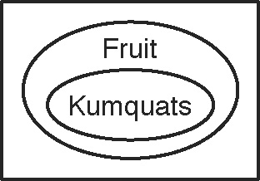
4.

Determine if each conditional is true. If false, give a counterexample.
5. If two points are noncollinear, then a right triangle contains one obtuse angle.

6. If a liquid is water, then it is composed of hydrogen and oxygen.

7. If a living thing is green, then it is a plant.

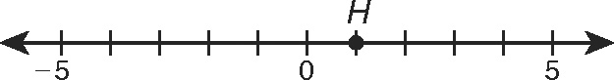
8. “If G is at 4, then GH is 3.” Write the converse, inverse, and contrapositive of this
statement. Find the truth value of each.
Converse:
Inverse:
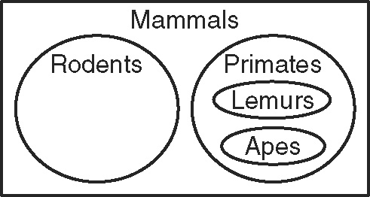
Contrapositive:
This chart shows a small part of the Mammalia
class of animals, the mammals. Write a conditional
to describe the relationship between each given pair.
9. primates and mammals
10. lemurs and rodents
11. rodents and apes
12. apes and mammals
A biconditional statement combines a conditional statement, “if p, then q,” with its converse, “if q, then p.”

Biconditional: The sides of a triangle are congruent if and only if the angles are congruent.
Write the conditional statement and converse within each biconditional.
1. Lindsay will take photos for the yearbook if and only if she doesn’t play soccer.

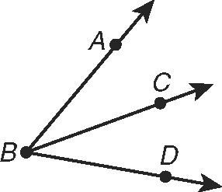
2. m∠ABC = m∠CBD if and only if is an angle bisector of ∠ABD.

For each conditional, write the converse and a biconditional statement.
3. If you can download 6 songs for $5.94, then each song costs $0.99.

Write True or False for each statement. A biconditional is true only if both the conditional and the converse are true. If the biconditional is false, give a counterexample.
4. Conditional: If x = 1, then x > 0.
Converse: If x > 0, then x = 1.
Biconditional: x = 1 if and only if x > 0.
Counterexample:
8. Conditional: If it is 3:30 a.m., then it is night.
Converse: If it is night, then it is 3:30 a.m.
Biconditional: It is 3:30 a.m. if and only if it is night.
Counterexample:

