Conditional Statements
A conditional statement is a statement that can be written as an if-then statement,
“if p, then q.”
The conclusion comes after the word then.
The hypothesis comes after the word if.

If you buy this cell phone, then you will receive 10 free ringtone downloads.
Sometimes it is necessary to rewrite a conditional statement so that it is in if-then form.
Conditional: A person who practices putting will improve her golf game.
If-Then Form: If a person practices putting, then she will improve her golf game.
A conditional statement has a false truth value only if the hypothesis (H) is true and
the conclusion (C) is false.
For each conditional, underline the hypothesis and double-underline the conclusion.
1. If x is an even number, then x is divisible by 2.
2. The circumference of a circle is 5π inches if the diameter of the circle is 5 inches.
3. If a line containing the points J, K, and L lies in plane then J, K, and L are coplanar.
For Exercises 4–6, write a conditional statement from each given statement.
4. Congruent segments have equal measures.

5. On Tuesday, play practice is at 6:00.

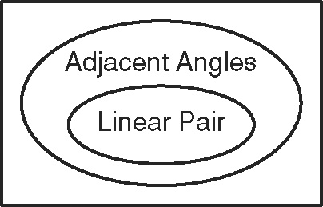
6.

Determine whether the following conditional is true. If false, give a counterexample.
7. If two angles are supplementary, then they form a linear pair.

Conditional Statements (back)
The negation of a statement, “not p,” has the opposite truth value of the original statement.
If p is true, then not p is false.
If p is false, then not p is true.
Statement | Example | Truth Value
Conditional | If a figure is a square, then it has four right angles. | True
Converse:  Switch H and C. | If a figure has four right angles, then it is a square. | False
Inverse:  Negate H and C. | If a figure is not a square, then it does not have four right angles. | False
Contrapositive:  Switch and  negate H and C. | If a figure does not have four right angles, then it is not a square. | True

H
C

Write the converse, inverse, and contrapositive of each conditional statement.
Find the truth value of each.
8. If an animal is an armadillo, then it is nocturnal.

9. If y = 1, then y ² = 1.

10. If an angle has a measure less than 90°, then it is acute.

