`sd
Precision & Accuracy
Standard: SWABAT interpret parts of an expression, such as terms, factors, and coefficients. (MCC912.A.SSE.1a)

Name: ___________________________________ Mr. Murphey’s Coordinate Algebra
Date: 1/14/2014 Block: 1 4
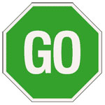

Inbox Task - Evaluate each expression for a = 3, b = –2, c = 5.

1. 4a – b
2. 3b² – 5
3. ab – 2c

Solve each proportion.
4. $\frac{6}{m}=\frac{2}{3}$ 5. $\frac{x}{8}=\frac{4}{5}$
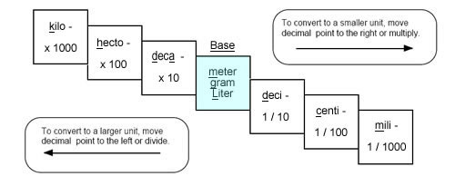

Unit Conversion Chart

Distance: Weight: Volume (liquids):


1 mile = 5,280 feet 1 ton = 2,000 pounds 1 gallon = 4 quarts
1 yard = 3 feet 1 pound = 16 ounces 1 quart = 2 pints
1 foot = 12 inches 1 pint = 2 cups
1 cup = 8 ounces
To Convert Between English and Metric:
1 inch = 2.54 cm.
1 quart = 946 mL
1 pound = 454 grams

Unit Conversion Practice

- 1.347 L = ____ mL

- 52 qt = ____ ga

- 1760 yd = ____mi

- 3.2 mi = ____ yd

- 2750 lb = ____ kg

- 940 mm = ____ cm

- 876 mL = ____ L

- 5675 ft = ____ mi

- 2750 lb = ____ ton

- 3.2 mi = ____ in

Word Problems

- Convert 760 minutes to days

- A building is 1,275 feet tall. How many yards tall is this building?
- Convert 3.725 kilometers to meters.

- If 1 inch = 2.54 centimeters, how tall is Marty, to the nearest centimeter, if he is 6 feet tall?

- You’re traveling in Canada and a sign says the temperature 25º Celsius (C). What is it in degrees Fahrenheit (F)? ( 1.6º C = 1º F)

Precision and Accuracy
Choose the more precise measurement in each pair. If they are equally precise, write "neither."
1. 5.26 kg; 5260.0 g 2. 48 mg; 0.048 g 3. 4.2 cm; 420.0 mm

4. 5.1 lb; 82.1 oz 5. 4.1 L; 4102 mL 6. 128 min; 2.1 hr

Write the possible range of each measurement to the nearest hundredth.
7. 70 m ± 6.5% 8. 62.5°F ± 8.2% 9. 22.5 mg ± 5%

Rewrite each specified tolerance as a percent.
10. 120 lb ± 4.8 lb 11. 300 cm ± 22.5 cm 12. 210 ft ± 19.11 ft

13. A professional baseball's circumference and weight must fall within given tolerance levels of regulation measurements. The table shows these tolerance levels as well as measurements taken on three different baseballs. Which baseball meets both of the specified tolerances?
 | Circumference (cm) | Weight (oz)
Tolerance | 23.1775 ± 0.3175 | 5.125 ± 0.125
Baseball #1 | 24.005 | 5.249
Baseball #2 | 23.382 | 5.181
Baseball #3 | 23.997 | 4.998

14. Rolondo is measuring the length of his lawn. Using a board that is 10 feet long, he measures his lawn to be 70 feet long. He then uses his foot, which is 12 inches long, to measure his lawn to be 864 inches. Which is the more precise measurement? Which is the more precise tool?

15. A bolt used to assemble a car must have a length of 37.5 mm ± 4%. Does a bolt that is 39.3 mm long fall within the specified tolerance? Why or why not?

