`sd
Precision & Accuracy
Standard: SWABAT interpret parts of an expression, such as terms, factors, and coefficients. (MCC912.A.SSE.1a)

Name: ___________________________________ Mr. Murphey’s Coordinate Algebra
Date: 1/15/2014 Block: 1 4


Inbox Task - Complete the table below and use it to answer questions 5–8. Select the best answer. Assume the shadow lengths were measured at the same time of day.

Object | Length of Shadow (ft) | Height (ft)
Flagpole | 8 | 20
Oak tree | 12
Goal post | 18
Telephone pole |  | 17.5
Fence |  | 6.5
15. The flagpole casts an 8 foot shadow, as shown in the table. At the same time, the oak tree casts a 12 foot shadow. How tall is the oak tree?
A 4.8 ft C 30 ft
B 24 ft D 32 ft
2. How tall is the goal post?
F 7.2 ft H 38 ft
G 30 ft J 45 ft

3. What is the length of the telephone pole’s shadow?
A 5.5 ft C 25.5 ft
B 7 ft D 43.8 ft
4. What is the length of the fence’s shadow?
F 1.5 ft H 16.25 ft
G 2.6 ft J 21.5 ft

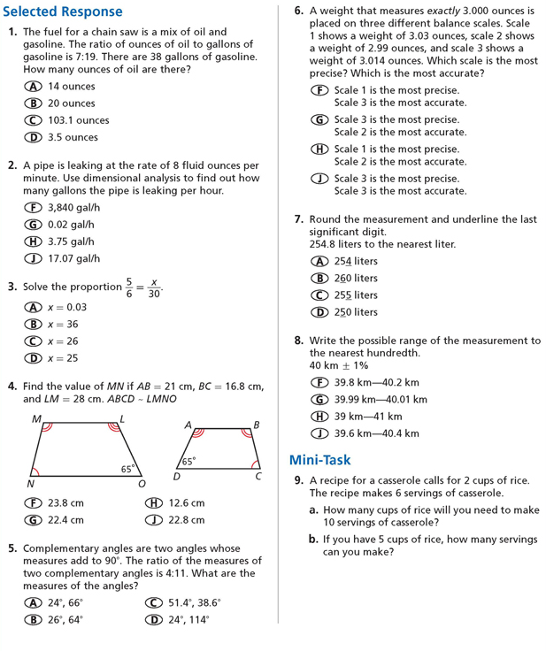

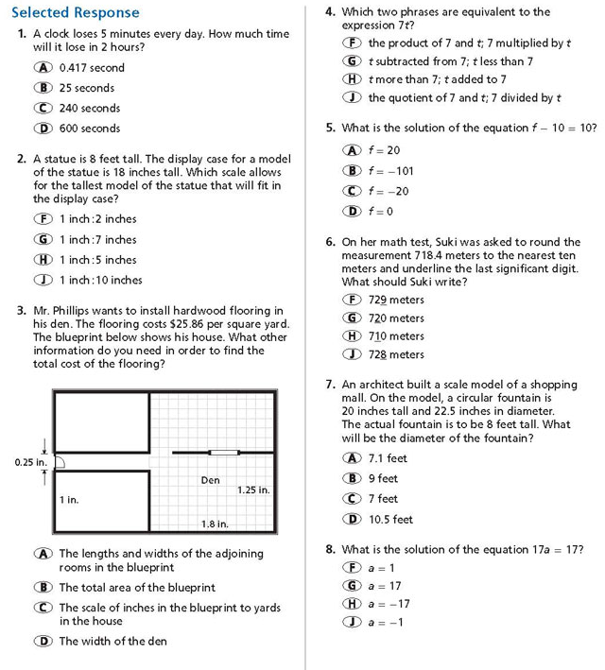

Write the correct answer.

1. Rolondo is measuring the length of his lawn. Using a board that is 10 feet long, he measures his lawn to be 70 feet long. He then uses his foot, which is 12 inches long, to measure his lawn to be 864 inches. Which is the more precise measurement? Which is the more precise tool?
2. A bolt used to assemble a car must have a length of 37.5 mm ± 4%. Does a bolt that is 39.3 mm long fall within the specified tolerance? Why or why not?
3. According to the Billiard Congress of America, BCA Equipment Specification, the diameter of a billiard ball is 2.25 inches with a tolerance of 0.005 inch. Which billiard ball(s) in the table below meet(s) this standard?
Ball | 1 | 2 | 3 | 4 | 5
Diameter | 2.255 | 2.249 | 2.251 | 2.250 | 2.2
Ball | 6 | 7 | 8 | 9 | 10
Diameter | 2.251 | 2.244 | 2.239 | 2.249 | 2.251
Ball | 11 | 12 | 13 | 14 | 15
Diameter | 2.250 | 2.219 | 2.247 | 2.257 | 2.288

