Intelligence and Goals

Standard: SWABAT Interpret parts of an expression, such as terms, factors, and coefficients. (MCC912.A.SSE.1a)

Name: ___________________________________ Mr. Murphey’s Coordinate Algebra
Date: 8/19/2013 Block: 2




Inbox Task Write the correct abbreviation for each metric unit.
1) Kilogram _____ 4) Milliliter _____ 7) Kilometer _____

2) Meter _____ 5) Millimeter _____ 8) Centimeter _____

3) Gram _____ 6) Liter _____ 9) Milligram _____

Unit Conversion
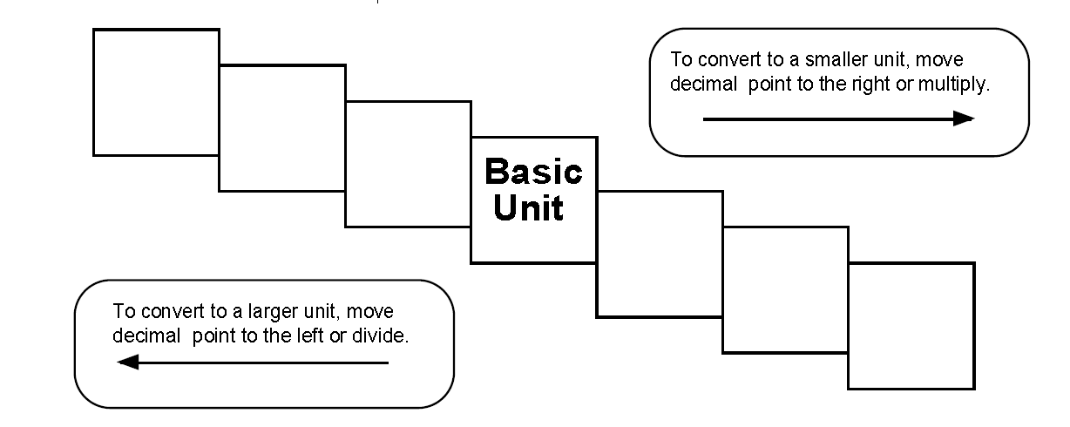
Try these metric conversions, using the ladder method.
1000 mg = _______ g 1 L = _______ mL

160 cm = _______ mm 14 km = _______ m

109 g = _______ kg 250 m = _______ km

Try these conversions, using the ladder method.
1) 2000 mg = _______ g 6) 5 L = _______ mL 11) 16 cm = _______ mm

2) 104 km = _______ m 7) 198 g = _______ kg 12) 2500 m = _______ km

3) 480 cm = _____ m 8) 75 mL = _____ L 13) 65 g = _____ mg

4) 5.6 kg = _____ g 9) 50 cm = _____ m 14) 6.3 cm = _____ mm

5) 8 mm = _____ cm 10) 5.6 m = _____ cm 15) 120 mg = _____ g

Conversions
1 hour = 3600 seconds 1 mile = 5280 feet 1 yard = 3 feet
1 meter = 3.28 feet 1 km = 0.62 miles 1 light second = 300,000,000 meters
1 kg = 2.2 lbs 1 lb = 0.45 kg 1 quart = 0.946 liters
1km = 1000m 1 foot = 12 inches 1 inch = 2.54 cm = 25.4 mm
100cm = 1 m

Convert the following quantities.

- 565,900 seconds into days

- 17 years into minutes

- 43 miles into feet

- 165 pounds into kilograms

- 100 yards into meters

- 22,647 inches into miles

- 2678 cm into feet

- 60 miles per hour into meters per second

- 130 meters per second into miles per hour

- 1100 feet per second into miles per hour

11) Write your own unit conversion using any of the units above.

