Variables and Expressions

Standard: SWABAT Interpret parts of an expression, such as terms, factors, and coefficients. (MCC912.A.SSE.1a)

Name: ___________________________________ Mr. Murphey’s Coordinate Algebra
Date: 8/20/2013 Block: 2




Inbox Task Complete the following pre-assessment
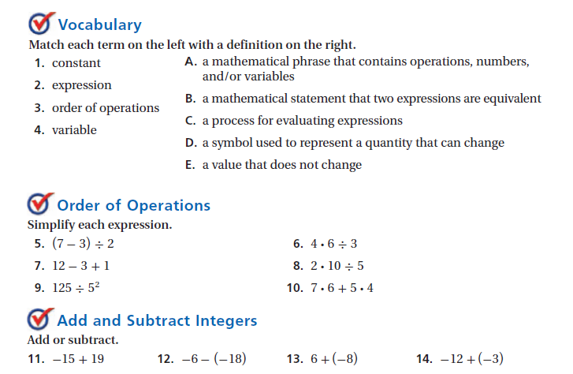

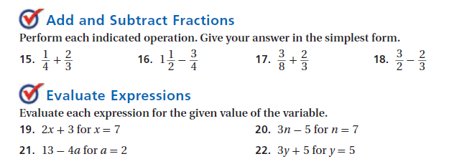

Which of these sections is most difficult?

Word Problem Translations
Translations: Fill in the appropriate words for each math operation.

- Half
- Plus
- Triple
- More Than
- Difference
- To the power of
- Sum
- Decreased
- Twice
- Less Than (swaps the order)
- Raised to a power
- Take away
- Increased
- Cubed
- Minus
- Quotient
- Product
- Divide by
- Double
- Add
- Times
- Together
- Square

Addition- (6 words) Multiplication- (5 words)

Subtraction- (5 words) Exponents- (4 words)

Division- (3 words)

Practice
Translate each verbal expression to an algebraic expression.

- Eight more than 5 times a number

- The difference of 6 and a number

- The quotient of 4 and a number

- 12 less than twice a number

- Three-fourths the square of number

- The product of 5 and the cube of a number increased by the difference of 6 and x

- Half the sum of x and y decreased by one-third of y

- The sum of a number and six, divided by eight

Translate each algebraic expression to a verbal expression.

- $22-x$

- $x^{3}-10$
- $2+\frac{1}{2}x$

- $4^{3}+3$

