Review Graphing
Objective: SWABAT Graph transformations of basic functions: vertical shifts, stretches, shrinks and reflections.
Name: ___________________________________ Mr. Murphey’s Coordinate Algebra Support
Date: 8/20/2013 Block: 1 4



Inbox Task

- $6a(2a-3$)

- $4t(t^{2}+2t-6$)

- $(v-4)(v+6$)
- $(2y-3)(y^{2}+3y-5$)

Review Homework

Graphing -Label the coordinate plane
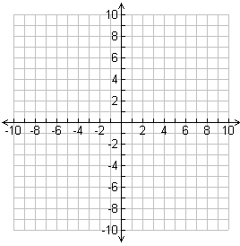

- Graph and label the following points
A (3, -4), B (5, 6), C (-4, 5) and D (-7, -5)
- Graph and label the following points
A (2,6) B (-4,-8) C (10, -2) D(-3, 5

Graphing Equations
- $y = x$
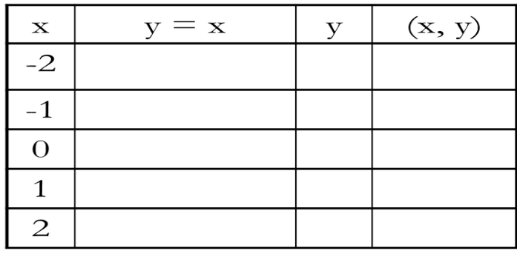

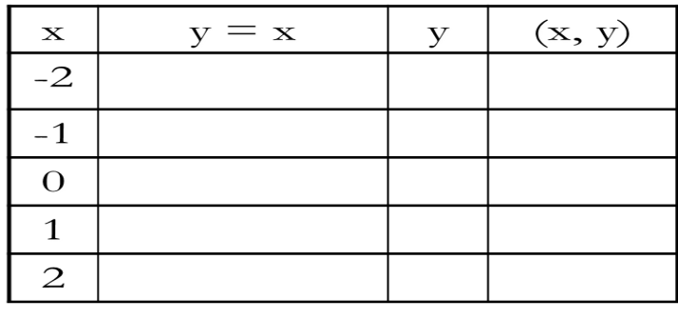
4. $y = -2x + 5$

3. $f(x) = |x|$
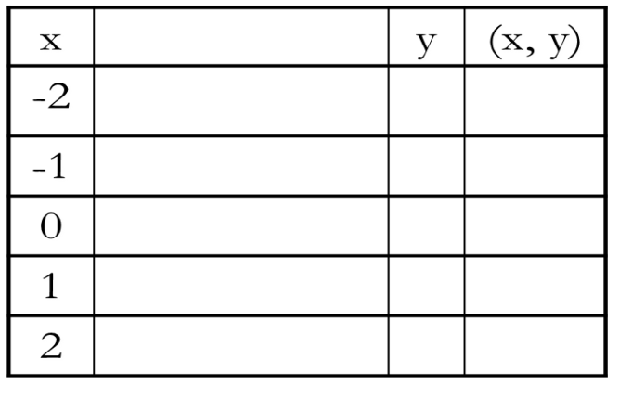
4. $f(x) = |x + 2| - 1$

5. $y = x^{2}$

6. $f(x) = 2x^{2} – 5$

Find the range of the given domain of f(x) = -3x + 5
x | -5 | -4 | -3 | -2 | -1 | 0 | 1 | 2 | 3 | 4 | 5
f(x)

Name: ______________________________________ Block 1 4
Due Date: 8/21/2013 Homework: Graphing

Graph the following functions
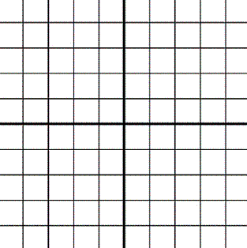
1. $y = x+ 1$ 2$. y = -2x+2$

Name: ______________________________________ Block 1 4
Date: 8/20/2013

___ / ___
Exit Ticket 1: Function Notation

- Write $y=3x^{2}+2$ in function notation

- Is h(x) the input or output?

- Insert input and output, dependent and independent, and domain and range in the proper place
x | y
- Graph $f\left(x\right)= x^{2}+2$

- Describe the transformation that occurred from the
parent graph?

Name: ______________________________________ Block 1 4
Date: 8/20/2013

___ / ___
Exit Ticket 1: Function Notation

- Write $y=3x^{2}+2$ in function notation

- Is h(x) the input or output?

- Insert input and output, dependent and independent, and domain and range in the proper place
x | y
- Graph $f\left(x\right)= x^{2}+2$

- Describe the transformation that occurred from the
parent graph?

