Name: ___________________________________ Mr. Murphey’s Analytical Geometry
Date: 1/22/2014 Block: 2
Standard: SWABAT Prove geometric theorems about lines and angles. (MCC912.G.CO.9)

Angles Formed by Lines


Inbox Task – Identify each angle pair.

- ∠1 and ∠3

2. ∠3 and ∠6
3. ∠4 and ∠5

4. ∠6 and ∠7
Angles Formed by Parallel Lines and Transversals
1. The Corresponding Angles Postulate states that if two parallel lines are cut by a
transversal, then the pairs of corresponding angles are ____________________.

2. Congruent angles have _____________________ measures.

Find each angle measure.
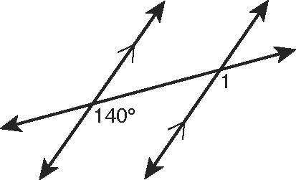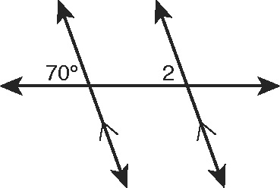
3. m∠1 _______________________ 4. m∠2 _______________________

Find x.
5. 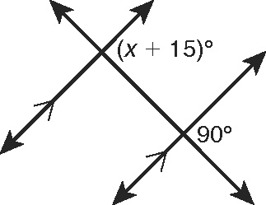 6. 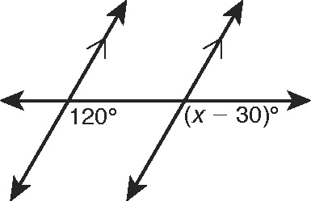

Fill in the blanks to complete these theorems about angle pairs.
7. If two _____________________ lines are cut by a _____________________,
then the two pairs of alternate interior angles are congruent.
8. If two parallel lines are cut by a transversal, then the two pairs of same-side
interior angles are _____________________.
9. If two parallel lines are cut by a transversal, then the two pairs of alternate
exterior angles are _____________________.

Give two examples of each kind of angle pair in the figure.
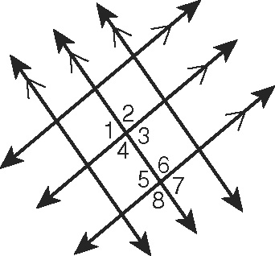
10. alternate interior angles 11. alternate exterior angles

12. same-side interior angles

Find each angle measure.
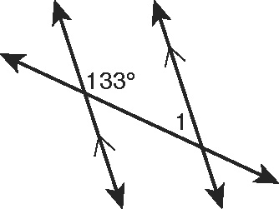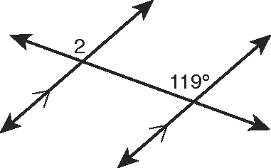
13. m∠1 _______________________ 14. m∠2 _______________________
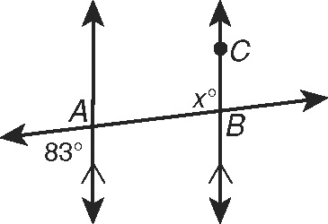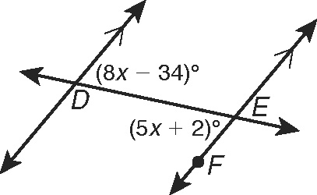
15. m∠ABC _______________________ 16. m∠DEF _______________________
Complete the two-column proof to show that same-side exterior angles
are supplementary.
17. Given: p || q
Prove: m∠1 + m∠3 = 180°
Proof:
Statements | Reasons
1. p || q | 1. Given
2. a. _______________________ | 2. Lin. Pair Thm.
3. ∠1 ≅ ∠2 | 3. b. _______________________
4. c. _______________________ | 4. Def. of ≅
5. d. _______________________ | 5. e. _______________________
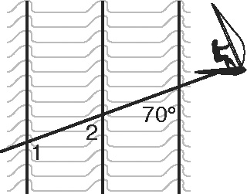
18. Ocean waves move in parallel lines toward the shore.
The figure shows Sandy Beaches windsurfing across
several waves. For this exercise, think of Sandy’s wake
as a line. m∠1 = (2x + 2y)° and m∠2 = (2x + y)°.
Find x and y.
x = _________
y = _________
19. In the diagram of movie theater seats, 20. In the diagram, roads a and b are parallel.
the incline of the floor, f, is parallel to
the seats, s.
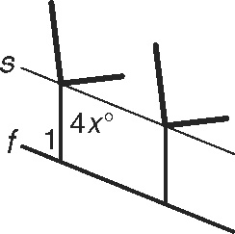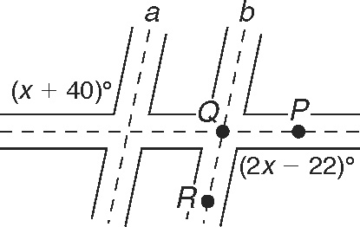
If m∠1 = 68°, what is x? What is the measure of ∠PQR?

