`sd
Solving Equations
Standard: SWABAT Solve linear equations and inequalities in one variable, including variable coefficients. (MCC912.A.REI.3)

Name: ___________________________________ Mr. Murphey’s Coordinate Algebra
Date: 1/23/2014 Block: 1 4


Inbox Task – simplify

1. 4x – 10x
2. –7(x – 3)
3. $\frac{1}{3}(6x+9)$
4. 15 – (x – 2)
Solve.
5. 3x + 2 = 8

6. $\frac{1}{3}x-\frac{1}{3}=9$

Solving Two-Step and Multi-Step Equations Solve each equation. Check your answers.
1. 5r + 2 = 17 2. 25 = −2w − 3 3. −7 = 4y + 9

4. −3f + 19 = 4 5. −22 = −p − 12 6. 6.5 = 2.5r − 11

7. $\frac{y}{3}$ − 8 = 1 8. $\frac{2h}{3}$ − $\frac{1}{4}$ = $\frac{1}{3}$ 9. $-\frac{2}{5}$ = −$\frac{1}{3}$m $+\frac{3}{5}$

10. −5v = 6v + 5 − v 11. −3(b + 9) = −6 12. 6 = −4(n − 1)

13. If 9x − 13 = −31, find the value of x − 8. _____________________________________

14. If 4 = −18, find the value of 2y. _____________________________________

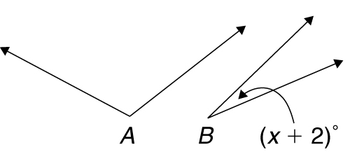
Answer each of the following.
15. Angle A is three
times the size of
angle B. The sum
of the angle measures
is 128°. Find the value of x.

16. Tina sold cookies at her club’s bake sale. She
spent $18.50 on supplies. She sold her cookies
for $0.75 each and made a profit of $24.25.
Write and solve an equation to find how
many cookies Tina sold.

Solving Equations with Variables on Both Sides Solve each equation. Check your answers.
1. 9x − 2 = 2x + 12 2. 2a − 11 = −8a + 19 3. 2c + 6 = 1 − 3c

4. −y − 22 = y − 16 5. 5d − 8 = 3 + 7d 6. 9 + 2.7t = −4.8t − 6
7. −5m + 2 + 8m = 2m + 11 8. −y − 8 + 6y = −9 + 5y + 1

9. 4(2x − 3) = 3 + 8x − 11 10. 2 = n + 1 + n −

Answer each of the following.
11. The table at right shows the costs of ordering
T-shirts from two different companies. With
how many T-shirts would the cost of the order
be the same with both companies? What
would that cost be?
Company | Price Per Shirt | Shipping
Crazy Shirts | $8.00 | $13.00
T’s for All | $7.50 | $16.00

12. Brenn has $60 in his savings account. His brother Chris
has $135 in his. Brenn decides to save $5 of his allowance
each week, while Chris decides to spend his whole allowance
along with $10 of his savings each week. After how many weeks
will Brenn and Chris have the same amount of money in their
savings accounts? How much money will that be?

Write the correct answer.
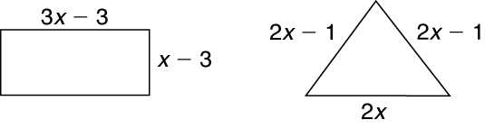
1. Claire purchased just enough fencing to 2. Celia and Ryan are starting a nutrition
border either a rectangular or triangular program. Celia currently consumes
garden, as shown, whose perimeters 1200 calories a day and will increase
are the same. that number by 100 calories each day.
Ryan currently consumes 3230 calories
a day and will decrease that number by
190 each day. They will continue this
pattern until they are both consuming
the same number of calories per day. In
How many feet of fencing did she buy? how many days will that be?

3. A moving company charges $800 plus 4. Aaron needs to take out a loan to
$16 per hour. Another moving company purchase a motorcycle. At one bank, he
charges $720 plus $21 per hour. How would pay $2500 initially and $150
long is a job that costs the same no each month for the loan. At another
matter which company is used? bank, he would pay $3000 initially and
$125 each month. After how many
months will the two loan payments be
the same?

Finding a Formula to Solve Linear Equations
A linear equation in one variable can take on many different appearances. Each of the equations below is an equation in one variable.
2x − 5 = 12 2(x + 1) = 5 3x − 4 = −2x + 1
Although these equations look different, you can transform each of them into the standard form for a linear equation in one variable.

In Exercises 1−4, each equation has the form ax + b = 0. Solve each equation.
1. 3x + 7 = 0 _________________ 2. −2x − 8 = 0 _________________

3. x − 5 = 0 _________________ 4. −4.1x − 8.2 = 0 _________________

You can always transform a given linear equation in one variable into the form ax + b = 0.
In Exercises 5−8, write each equation in the form ax + b = 0. Do not solve the resulting equation.
5. 3(x + 5) = x + 21 6. −2(−4 − 6x) = −10 + 3x

7. −7(−3 − x) = −2(3 − x) 8. 8 − 2(x − 5) = x − 3

9. a. Solve ax + b = 0 for x.

b. Explain how to write your answer to part a as a formula that you can use to solve a linear equation in x.

Solve the specified equation by using your formula from Exercise 9.
10. Exercise 5 ___________________________ 11. Exercise 6

12. Exercise 7 ___________________________ 13. Exercise 8

14. a. Let ax + b = 0, where a = 0 and b = 0. How many
solutions does the equation have?
b. Let ax + b = 0, where a = 0 and b ≠ 0. How many
solutions does the equation have?

