Ratio Applications
Standard: SWABAT Interpret parts of an expression, such as terms, factors, and coefficients. (MCC912.A.SSE.1a)

Name: ___________________________________ Mr. Murphey’s Coordinate Algebra
Date: 8/29/2013 Block: 2




Inbox Task – Solve 1-6
1. The ratio of boys to girls in college now is almost 3:7. There are 21,000 girls at UGA. How many boys do we expect? ___________________________
Find each unit rate.

- .5 mi = ____ in

- 1m = ____ in

Solve each proportion. 4. $\frac{6}{m}=\frac{2}{3}$ 5. $\frac{x}{8}=\frac{4}{5}$

Literal Equations & Dimensional Analysis
Conversions Factors

1 hr = 60 min | 1 min = 60 sec | 1 ton = 2000 lbs | 7 days = 1 week | 0.621 mi = 1.00 km
24 hrs = 1 day | 1 kg = 2.2 lbs | 1 gal = 3.79 L | 264.2 gal = 1 cubic meter | 1 yd = 36 inches
1 mi = 5,280 ft | 1 kg = 1000 g | 1 lb = 16 oz | 20 drops = 1 mL | 1 cc is 1 cm³
365 days = 1 yr | 52 weeks = 1 yr | 2.54 cm = 1 in | 1 L = 1000 mL | 1 mL = 1 cm³
Solve each problem using dimensional analysis. Every number must have a unit. Work must be shown.
Keys: What do I want? What are the units for it? What do I have? What are the units?

- Stefan loves playing basketball. He comes up with a plan to work on his free throws every day until the season starts. He’s going to shoot 100 free throws every day for the next 12 weeks. How many free throws will he shoot over the 12 weeks?

- A child requires a 5 ml dose of medicine each day. How many days would a gallon of this medicine last?

- How many miles will a person run during a 10 kilometer race?

- The moon is 250,000 miles away. How many feet is it from earth?

- A small herd of cattle consumes fourteen bales of hay in two weeks. How many bales will this herd consume in a year?

- Saffron costs $368.00 per ounce. Determine how many grams you can purchase for $15.00.

- Tiana purchases 44 euros worth of souvenirs while on vacation in France. If $1 U.S. = 0.678 euros, find the cost of the souvenirs in U.S. dollars. Round to the nearest cent.

- If a 2 day rafting trip covers a distance of 60 miles and you are expected to raft 8 hours each day, how many miles must you raft each hour?

- You have been working at a fast food restaurant for the past 35 years wrapping hamburgers. Each hour you wrap 184 hamburgers. You work 8 hours per day, 5 days a week and get paid every 2 weeks with a salary of $840.34. How many hamburgers will you have to wrap to make your first one million dollars?

Applications of Proportions
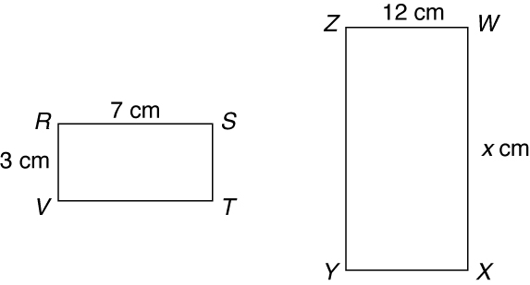
Find the value of x in each diagram.
1. ΔACD ∼ ΔDEF 2. RSTV ∼ WXYZ
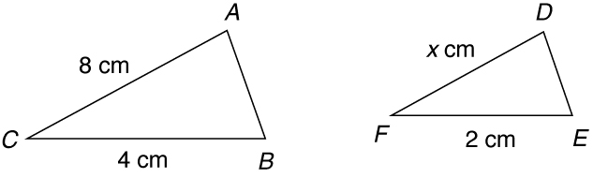

3. Sam is 5 feet tall and casts a shadow 4 feet long.
At the same time, a nearby tree casts a shadow
12 feet long. Write and solve a proportion to find
the height of the tree. _____________________________________
Every dimension of rectangle A has been multiplied by 2 to form rectangle B.
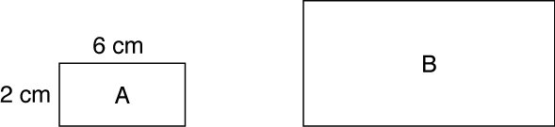

4. What are the new dimensions of rectangle B? _____________________________________

5. What is the ratio of the corresponding sides? _____________________________________
 | Rectangle A | Rectangle B
Perimeter
Area

6. Complete the table.

7. What is the ratio of the perimeters? _____________________________________

8. How is the ratio of perimeters related to the ratio in problem 5?

9. What is the ratio of the areas? _____________________________________

10. How is the ratio of the areas related to the ratio in problem 5?

