Ratio Applications
Standard: SWABAT Use units as a way to understand problems and to guide the solution (MCC912.N.Q.1)

Name: ___________________________________ Mr. Murphey’s Coordinate Algebra
Date: 8/30/2013 Block: 2




Inbox Task – Solve 1-5
Evaluate each expression for $a = 3$, $b = -2$, and $c =5.$

- $4a - b$

- $3{b }^{2} - 5$
3. $ab - 2c$

Solve each proportion. 4. $\frac{6}{m}=\frac{2}{3}$ 5. $\frac{x}{8}=\frac{4}{5}$

Applications of Proportions
Find the value of x in each diagram.
1. ΔABC ∼ ΔDEF 2. FGHJK ∼ MNPQR
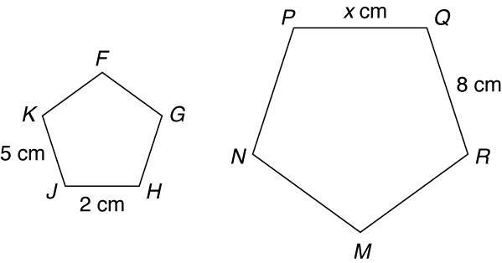
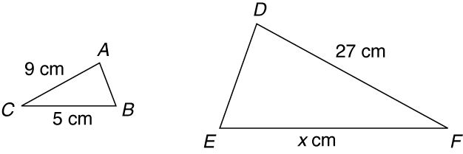

3. A utility worker is 5.5 feet tall and is casting a shadow
4 feet long. At the same time, a nearby utility pole casts
a shadow 20 feet long. Write and solve a proportion to
find the height of the utility pole. _____________________________________

4. A cylinder has a radius of 3 cm and a length of 10 cm.
Every dimension of the cylinder is multiplied by 3 to form
a new cylinder. How is the ratio of the volumes related to
the ratio of corresponding dimensions?

5. A rectangle has an area of 48 in². Every dimension of
the rectangle is multiplied by a scale factor, and the
new rectangle has an area of 12 in².
What was the scale factor? _____________________________________

Applications of Proportions
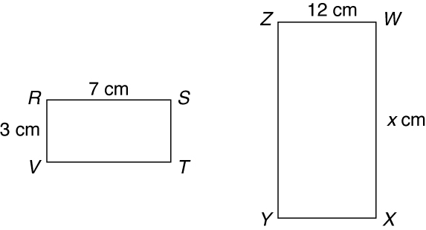
Find the value of x in each diagram.
1. ΔACD ∼ ΔDEF 2. RSTV ∼ WXYZ
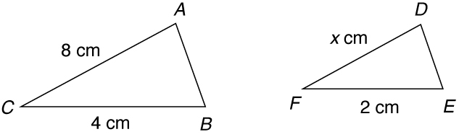

3. Sam is 5 feet tall and casts a shadow 4 feet long.
At the same time, a nearby tree casts a shadow
12 feet long. Write and solve a proportion to find
the height of the tree. _____________________________________
Every dimension of rectangle A has been multiplied by 2 to form rectangle B.
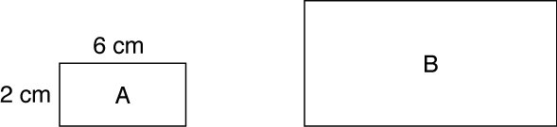

4. What are the new dimensions of rectangle B? _____________________________________

5. What is the ratio of the corresponding sides? _____________________________________
 | Rectangle A | Rectangle B
Perimeter
Area

6. Complete the table.

7. What is the ratio of the perimeters? _____________________________________

8. How is the ratio of perimeters related to the ratio in problem 5?

9. What is the ratio of the areas? _____________________________________

10. How is the ratio of the areas related to the ratio in problem 5?

