Name: ___________________________________ Mr. Murphey’s Analytical Geometry
Date: 1/21/2014 Block: 2
Standard: SWABAT interpret parts of an expression, such as terms, factors, and coefficients. (MCC912.A.SSE.1a)

Proofs


Inbox Task – Make a conjecture about each pattern. Write the next two items.
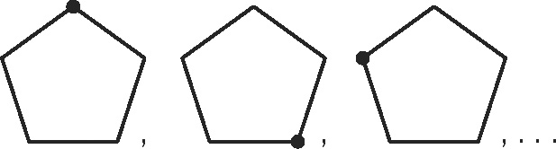
1. 1, 2, 3, 5, 8, 13, . . . 2.

College Name __________________ Average GPA ________ Average SAT __________
Proofs Fill in the blanks with the justifications and steps listed to complete each of the following two-column proofs. Use the choices found in the chart below the proof.
Given: ∠1 and ∠2 are straight angles.
Prove: ∠1 ≅ ∠2
Proof:
Statements | Reasons
1. a. _____________________________ | 1. Given
2. m∠1 = 180°, m∠2 = 180° | 2. b. _______________________________
3. m∠1 = m∠2 | 3. Subst. Prop. of =
4. c. ___________________________ | 4. Def. of ≅ ∠s

Choices: | ∠1 ≅ ∠2 | Def. of straight ∠ | ∠1 and ∠2 are straight angles.

Now try to fill in the blanks without being provided the choices.
2. Given: ∠JKL is a right angle.
Prove: ∠1 and ∠2 are complementary angles.
Two-Column Proof:
Statements | Reasons
1. ∠JKL is a right angle. | 1.
2. | 2. Definition of right angle
3. m∠JKL = m∠1 + m∠2 | 3. Angle Addition Postulate
4. 90° = m∠1 + m∠2 | 4.

3. Given: V is the midpoint of SW, and W is the midpoint of VT.
Prove: SV WT ≅
Two-Column Proof:
Statements | Reasons
1. V is the midpoint of SW | 1. Given
2. | 2. Given
3. | 3. Definition of midpoint
4. SV ≅ WT | 4. Transitive Property of Congruency
4.Given: AB ≅ BC and BC ≅ DE
Prove: AB ≅ DE
Two-Column Proof:
Statements | Reasons
1. | 1. Given
2. AB = BC, BC = DE | 2. Definition of congruent segments
3. AB = DE | 3.
4. AB ≅ DE | 4. Definition of congruent segments

Now try #5 and #6 on your own

4. Given: ∠1 and ∠2 form a linear pair, and
∠3 and ∠4 form a linear pair.
Prove: m∠1 + m∠2 + m∠3 + m∠4 = 360°
Proof:

Statements | Reasons

5. Given: ∠4 and ∠5 are supplementary and
∠5 and ∠6 are supplementary.
Prove: ∠4 ≅ ∠6
Proof:
Statements | Reasons

