`sd
Graphing Inequalities
Standard: SWABAT Solve linear equations and inequalities in one variable, including variable coefficients. (MCC912.A.REI.3)

Name: ___________________________________ Mr. Murphey’s Coordinate Algebra
Date: 1/27/2014 Block: 1 4


Inbox Task – Write <, >, or =.
- –3 2

- 6.5 6.3

- $\frac{1}{2} -\frac{3}{4}$

- $.25 \frac{1}{4}$
Tell whether the inequality x < 5 is true or false for the following values of x.
- $x=-10$
- $x=5$
- $x=4.99$
- $x=-\frac{1}{5}$

Graphing and Writing Inequalities
Describe the solutions of each inequality in words.
1. 2m ≥ 6
2. t + 3 < 8
3. 1 < x − 5
4. −10 ≥ c
Graph each inequality.
5. x > −7 6. p ≥ 2³

7. 4.5 ≥ r 8. y < −

Write the inequality shown by each graph.
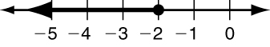
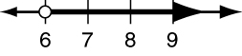
9. 10.

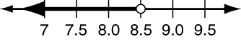
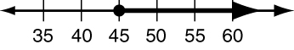
11. 12.

Define a variable and write an inequality for each situation. Graph the solutions.
13. Josephine sleeps more than 7 hours each night.

14. In 1955, the minimum wage in the U.S. was $0.75 per hour.
Graph each inequality.
15. k > −12 16. −6 ≤ w
7. b ≤ 2³ − 10 8. n < −

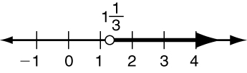
Write the inequality shown by each graph.
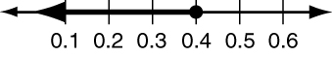
9. 10.

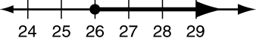
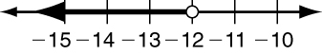
11. 12.

Define a variable and write an inequality for each situation.
13. To qualify for the job, applicants must have more than 3 years of experience in the field.

14. As of Aug. 1996, the speed limit on rural interstates in North Carolina is 70 mph.

When you graph the solutions of an inequality, you use a solid circle to show an endpoint that is a solution and an open circle to show an endpoint that is not. You use an arrow pointing to the right to show when solutions continue toward positive infinity and an arrow pointing to the left to show when solutions continue toward negative infinity. Interval notation is another way to show solutions of an inequality. In interval notation, the endpoints of the solutions are explicitly written out. Brackets or parentheses indicate whether or not the endpoints themselves are solutions. If the solutions continue toward infinity, an infinity symbol is written instead. The infinity symbol is always used with a parenthesis. Here are the graph and interval notation for x ≥ 1.
Interval Notation
[ or ] | endpoint is a solution
( or ) | endpoint is not a solution
(−∞ | solutions continue toward negative infinity
∞) | solutions continue toward positive infinity

The lower endpoint is 1,
and it is a solution.

The solutions continue toward positive infinity.

[1, ∞)
Complete the table. Problems 7–10 preview compound inequalities, which you’ll learn more about in Lesson 3–6.
 | inequality | graph | interval notation
1. | x > 4
2. |  |  | (−∞,−2]
3. | x < 3
4.
5. |  |  | (0, ∞)
6. | x ≤ −1
7. | −3 ≤ x ≤ 2
8. |  |  | (0, 3]
9. |  |  | [−4, 5)

