Graphing and Writing Inequalities pg. 40
Describe the solutions of x + 2 < 6.
Choose different values for x. Be sure to choose positive and negative values as well as zero.
 | x = 0 | x = 2 | x = −4 | x = 5 | x = 4 | x = 3 | x = 3.5
x + 2 < 6 | 0 + 2 < 6  2 < 6  True | 2 + 2 < 6  4 < 6  True | −4 + 2 < 6  −2 < 6  True | 5 + 2 < 6  7 < 6  False | 4 + 2 < 6  6 < 6  False | 3 + 2 < 6  5 < 6  True | 3.5 + 2 < 6  5.5 < 6  True

? ? ? ? ? ? ?
? ? ? ? ? ? ?

Plot the points on a number line. Use T to label points that make the inequality true.
Use F to label points that make the inequality false.
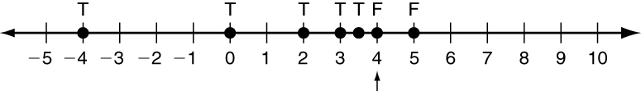
Look for the point at which the True statements turn to False statements. Numbers less than 4 make the statement true. The solutions are all real numbers less than 4.
Test the inequalities for the values given. Then describe the solutions of the inequality.
x = 0 | x = 1 | x = −3 | x = −4 | x = 2 | x = 3 | x = 1.5

1. 5x ≤ 10

x = 0 | x = 3 | x = −4 | x = −3 | x = −2 | x = −2.5 | x = −5

2. m + 1 < −2

Describe the solutions of each inequality in words.
3. > 4
4. g − 4 ≤ −3

Graphing and Writing Inequalities continued
Graph x ≤ 3.
Step 1: Draw a circle on the number.
Step 2: Decide whether to fill in the circle.
If > or <, leave empty.
If ≥ or ≤, fill in.
Step 3: Draw an arrow.
If < or ≤, draw arrow to left.
If > or ≥, draw arrow to the right.
Write the inequality shown by the graph.
Step 1: Write a variable and the number
indicated by the circle. x ? −4
Step 2: Look at the direction of the arrow.
If arrow points left, use < or ≤. x > or ≥ −4
If arrow points right, use > or ≥.
Step 3: Look at the circle.
If circle is empty, use > or <.
If circle is filled in use, ≥ or ≤. x > −4
Graph each inequality.
5. m ≥ 8 − 3 6. p < 3.5

Write the inequality shown by the graph.

7. 8.

