Precision and Accuracy Day 2
Standard: SWABAT choose a level of accuracy appropriate to limitations on measurement when reporting quantities. (CC912.N.Q.3)

Name: ___________________________________ Mr. Murphey’s Coordinate Algebra Support
Date: 9/4/2013 Block: 1 4

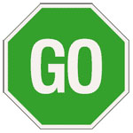


Inbox Task – Solve 1-6
Convert each measure.

- 12 ft to inch

- 57.3 cm to meters

- 2.5 days to seconds

- 73.235 is to the nearest tenth, hundredth or thousandths?

Are the given values in the range?

- $3±.25$

$$3.23, 2.78, 2.96, 3.27, 2.72$$

- $15±.5$

$$15.423, 14.798, 14.496, 15.349$$

Precision and Accuracy

Write the range shown on each number line to the nearest tenth.
1. 8.0 ± 1.0 2. 3.2 ± 0.8

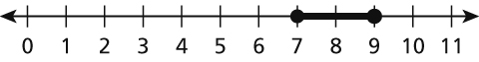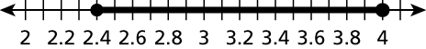

For 3 and 4, C represents the specified value. What is the tolerance?

3. 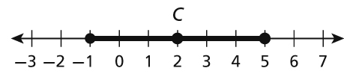 4. 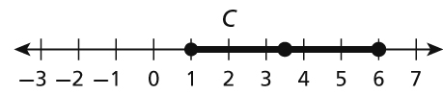

For 5 and 6, a specified value is given. Which point is most accurate?

5. Specified value: 3.19 6. Specified value: 6.05

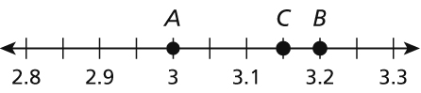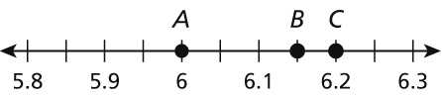

Precision and Accuracy Pre-Exit Ticket Practice

Choose the more precise measurement in each pair.
1. 2.78 L; 2782 mL 2. 6 ft; 72.3 in. 3. 2 c; 15 oz

4. 52 mm; 5.24 cm 5. 3 lb; 47 oz 6. 5.2 km; 5233 m

Write the possible range of each measurement. Round to the nearest hundredth if necessary.
7. 50 m ± 4% 8. 90 °F ± 15% 9. 15 L ± 2%

10. 16 ft ± 1.5% 11. 9 in. ± 10% 12. 66 g ± 3%

Use the following information for 13 and 14.
Marcel is measuring the volume of a liquid for chemistry class. He uses a beaker, a measuring cup, and a test tube. The teacher measures the liquid with a graduated cylinder, which gives the most accurate reading of 26.279 milliliters (mL). Marcel’s measurements are shown below.

Measuring Device | Measurement (mL)
Beaker | 26.3
Measuring Cup | 25
Test Tube | 26.21

13. Which device used by Marcel recorded the most precise measurement?

14. Which device used by Marcel recorded the most accurate measurement?

