Unit 1 Exam Day
Standard: SWABAT choose a level of accuracy appropriate to limitations on measurement when reporting quantities. (CC912.N.Q.3)

Name: ___________________________________ Mr. Murphey’s Coordinate Algebra Support
Date: 9/6/2013 Block: 1 4




Inbox Task – Solve 1-6
Convert each measure.

- 11 yards to inch

- 5.73 km to meters

- 1 year to seconds

- Which is more accurate? 73 mL or 73.0mL
Are the given values in the range?

- $30±2.5\%$

$$30.23, 27.8, 29.62, 31.27, 29.72$$

- $15±.5$

$$15.423, 14.798, 14.496, 15.349$$

Accuracy
- What is the most precise measurement this ruler can give for the line segment?
- 1 13/16 inches
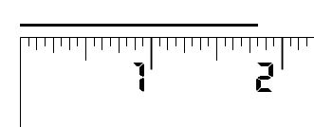
- 1 7/8 inches
- 1 3/4 inches
- 2 inches

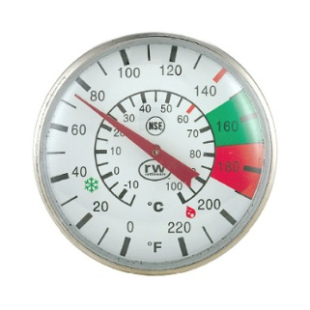
- The most accurate reading this thermometer can give (in °F) is to the nearest
- 1 degree
- 5 degrees
- 10 degrees
- 20 degrees
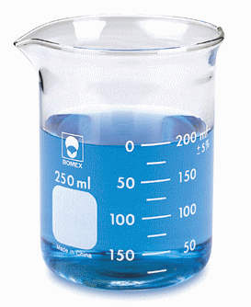
- What is the most precise measure this beaker can give?
- To the nearest 1 mL
- To the nearest 25 mL
- To the nearest 50 mL
- To the nearest 100 mL

- How precise can this protractor be?

- To the nearest degree
- To the nearest ten degrees
- To the nearest tenth degree
- To the nearest hundredth degree
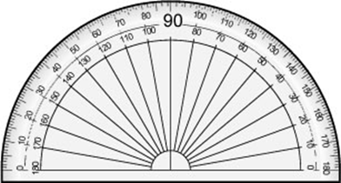

Unit Conversions Review- Round to nearest thousandth.
1. Convert 90 pounds to ounces.

- There are 5280 feet in one mile
- There are 0.034 ounces in one milliliter
- There are 0.454 kg in one pound
- There are 1.6 kilometers in one mile
- There are 73 gallons in 2 barrels
- There are 1.05 quarts in one liter
- There are 4 quarts in one gallon
- There are 16 ounces in a pound.

2. Convert 10 kilometers to miles.

3. Convert 100 barrels to quarts.

4. Convert from 0.37 miles to: a) feet and b) meters

5. How long does a car traveling at 70 mph take to travel 230 miles, in hours?

Word Problem Review
Short Answer. Show all of your work, including the equations.
6. Write an expression for three consecutive numbers (ie. 2,3,4 or 7,8,9)

- Find three consecutive integers whose sum is 81.

- April is moving apartments. Her family needs to rent a UHaul truck to transport their furniture. The rental company charges $19.99 for the truck. Then, they charge $0.20 per mile. Write an equation that represents how much it will cost to use the truck where x = the miles driven. How much will it cost if the family drives it 40 miles? If they end up spending $34.99, how far did they have to drive?

- Bill is building a sand box for his son to play in. The length is 2 feet more than the width. He has 20 feet of boards. What are the dimensions of his sand box?

Applications of Proportions
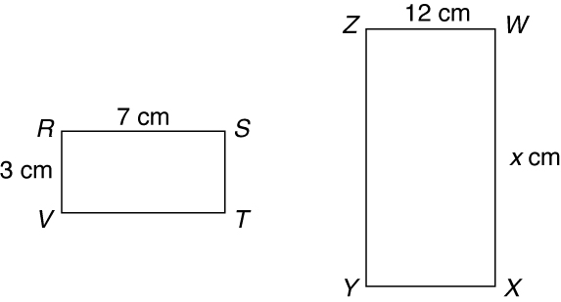
Find the value of x in each diagram.
1. ΔACD ∼ ΔDEF 2. RSTV ∼ WXYZ
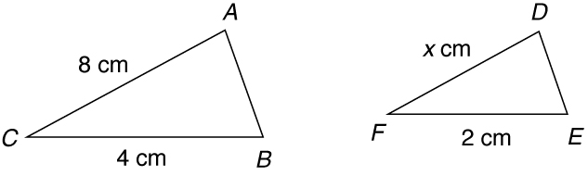

3. Sam is 5 feet tall and casts a shadow 4 feet long.
At the same time, a nearby tree casts a shadow
12 feet long. Write and solve a proportion to find
the height of the tree. _____________________________________
Every dimension of rectangle A has been multiplied by 2 to form rectangle B.
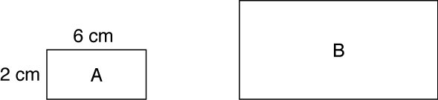

4. What are the new dimensions of rectangle B? _____________________________________
5. What is the ratio of the corresponding sides? _____________________________________
 | Rectangle A | Rectangle B
Perimeter
Area

6. Complete the table.

