`sd
Solving Inequalities
Standard: SWABAT Solve linear equations and inequalities in one variable, including variable coefficients. (MCC912.A.REI.3)

Name: ___________________________________ Mr. Murphey’s Coordinate Algebra
Date: 1/29/2014 Block: 1 4

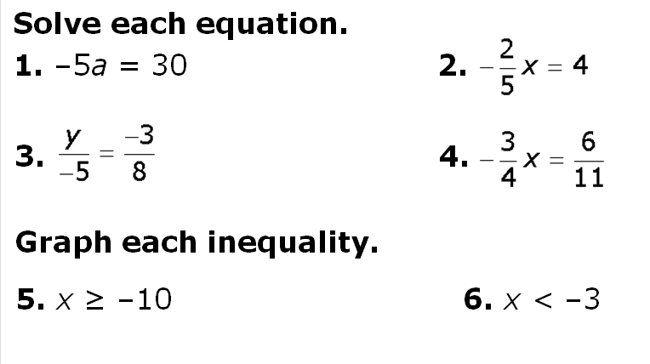

Inbox Task –

Solving Inequalities by Adding or Subtracting
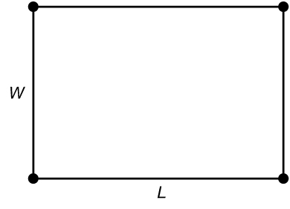
Susan has 200 feet of fencing and wants to use it to
enclose a rectangular garden. She knows that the formula
for the perimeter of a rectangle is P = 2(L + W). Susan
also knows that the area A of a rectangle is found by
using A = LW.
Answer the following questions in order to help Susan
plan how to use the fencing.
1. Susan can either use some or all of the fencing. Write an
inequality that describes how much fencing she could use. ___________________________

2. Would a length of 70 feet and a width of 40 feet satisfy the inequality in Exercise 1? Explain.

3. a. If Susan decides to use all of the fencing and chooses a length of 20 feet, find the width. ___________________________
b. What would the length be if she chooses a width of 20 feet? ___________________________
c. Given these dimensions, find the area of the garden. ___________________________

4. a. If Susan decides to use all of the fencing and chooses a length of 40 feet, find the width. ___________________________
b. What would the length be if she chooses a width of 40 feet? ___________________________
c. Given these dimensions, find the area of the garden. ___________________________
5. What conclusion can you draw from Exercises 3 and 4?

6. a. If Susan would like the length and the width to be as close to one another as possible and to be whole numbers, what might the dimensions be? ___________________________
b. Given her intention in part a, what shape is she trying to achieve? ___________________________
c. Given your answer to part a, find the area of the garden. ___________________________
7. Susan’s friend, Jack, has 160 feet of fencing. He wants to use all his fencing to make a garden with the greatest possible area. Without using inequalities, what dimensions should he choose? ___________________________

You will need a centimeter ruler for this activity.
1. Consider the inequality −1 < 3. Write the inequality
you get when you multiply both sides by −2. _____________________________________
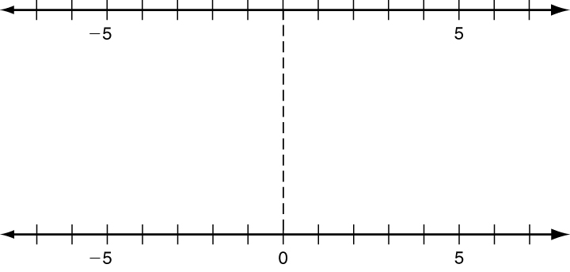
2. On the top number line, plot a point
at −1. On the bottom number line,
plot the value you get when you multiply
by −2. Use your ruler to connect the
two points with a straight segment.
3. Similarly, on the top, plot a point at 3.
On the bottom, plot the value you get
when you multiply by −2. Connect
the two points with a segment.
4. Explain how the graph illustrates that you reverse an inequality
when you multiply both sides by a negative number.

5. The two segments should intersect along the dashed segment
connecting the zeroes. Measure the two pieces of the dashed
segment. How is the ratio of the two lengths related to the factor −2?

6. Try it again. Multiply both sides of the inequality 9 < 15 by −.
Plot points and connect them. Do you see the same patterns?

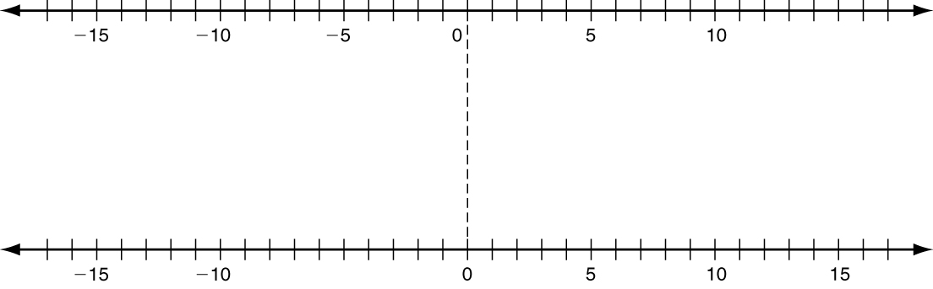
7. Where along the dashed line would the segments intersect
if you multiplied both sides of any inequality by −1?

