Name: ___________________________________ Mr. Murphey’s Analytical Geometry
Date: 2/4/2014 Block: 2
Standard: SWABAT Prove theorems about triangles. (MCC912.G.CO.6)

Angles in Triangles


Inbox Task –
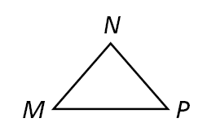
- Find the measure of exterior ∠DBA of BCD, if m∠DBC = 30°, m∠C= 70°, and m∠D = 80°.
- What is the complement of an angle with measure 17°?
- How many lines can be drawn through N parallel to MP? Why?

Angle Relationships in Triangles
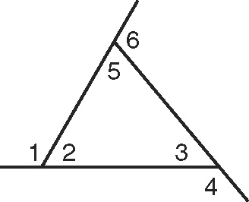
Use the figure for Exercises 1–3. Name all the angles that fit the definition of
each vocabulary word.
1. exterior angle
2. remote interior angles to ∠6
3. interior angle
For Exercises 4–7, fill in the blanks to complete each theorem or corollary.
4. The measure of each angle of an _______________ triangle is 608.
5. The sum of the angle measures of a triangle is _______________.
6. The acute angles of a _______________ triangle are complementary.
7. The measure of an _______________ of a triangle is equal to the sum
of the measures of its remote interior angles.
Find the measure of each angle.
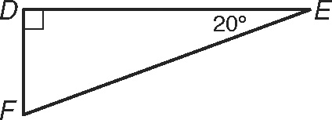
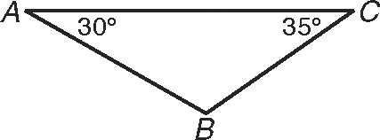
8. m∠B 9. m∠F
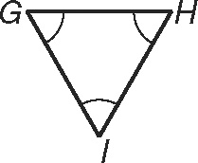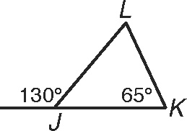
10. m∠G 11. m∠L
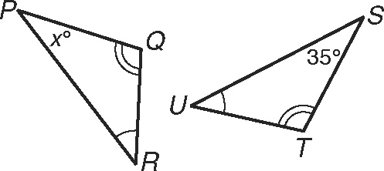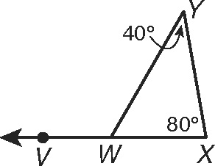
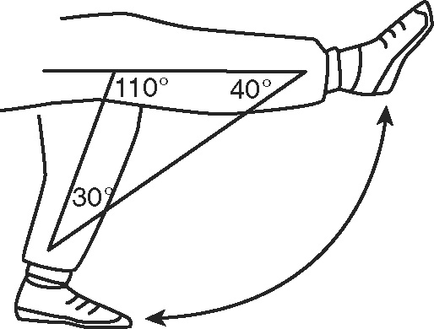
12. m∠P 13. m∠VWY
14. When a person’s joint is injured, the person often goes through rehabilitation under the supervision of a doctor or physical therapist to make sure the joint heals well. Rehabilitation involves stretching and exercises. The figure shows a leg bending at the knee during a rehabilitation session. Use what you know about triangles to find the angle measure that the knee is bent from the horizontal (fully extended) position.
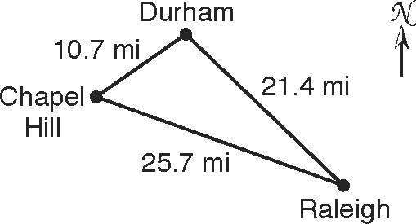
More Practice
- An area in central North Carolina is known as the Research Triangle because of the relatively large number of high-tech companies and research universities located there. Duke University, the University of North Carolina at Chapel Hill, and North Carolina State University are all within this area. The Research Triangle is roughly bounded by the cities of Chapel Hill, Durham, and Raleigh.
From Chapel Hill, the angle between Durham and Raleigh measures 54.8°. From Raleigh, the angle between Chapel Hill and Durham measures 24.1°. Find the angle between Chapel Hill and Raleigh from Durham.

2. The acute angles of right triangle ABC are congruent.
Find their measures.
The measure of one of the acute angles in a right triangle is given. Find the measure of the other acute angle.

3. 44.9° _____________ 4. (90 − z)° _____________ 5. 0.3° _____________
Find each angle measure.
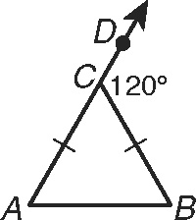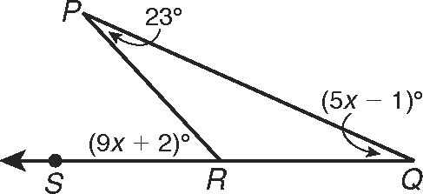
6. m∠B 7. m∠PRS
8. In LMN, the measure of an exterior angle at N measures 99°.
and . Find m∠L, m∠M, and m∠LNM.
9. m∠E and m∠G 10. m∠T and m∠V
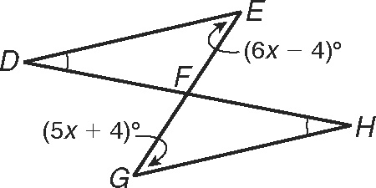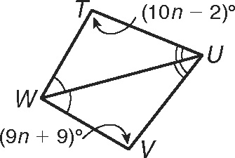
11. In ABC and DEF, m∠A = m∠D and m∠B = m∠E. Find m∠F if an exterior
angle at A measures 107°, m∠B = (5x + 2) °, and m∠C = (5x + 5) °.

12. The angle measures of a triangle are in the ratio 3 : 4 : 3. Find the angle measures of the triangle.

Find the measure of each angle.
13. In FGH, the measure of ∠H is 14° less 14. In WXY, the measure of ∠X is 4°
than the measure of ∠F. The measure less than twice the measure of ∠W.
of ∠G is 25° more than $2\frac{1}{3}$ times the The measure of ∠Y is 24° less than
measure of ∠F. Find m∠F. $3\frac{1}{32}$ times m∠W. Find m∠Y.

