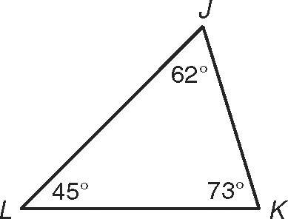
Angle Relationships in Triangles – pg. 52
According to the Triangle Sum Theorem, the sum of the angle
measures of a triangle is 1808.
m∠J + m∠K + m∠L = 62 + 73 + 45
= 1808
The corollary below follows directly from the Triangle Sum Theorem.
Corollary | Example
The acute angles of a right  triangle are complementary. | 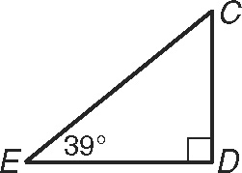  m∠C + m∠E = 908

m∠C = 90 − 39
= 518

Use the figure for Exercises 1 and 2.
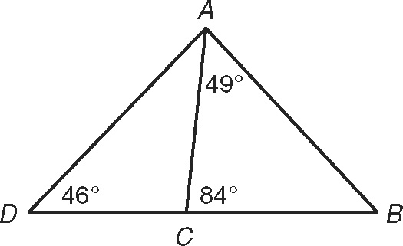
1. Find m∠ABC.

2. Find m∠CAD.

Use RST for Exercises 3 and 4.
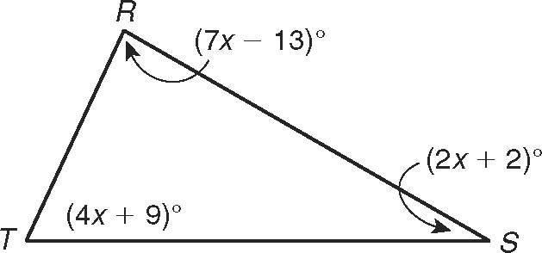
3. What is the value of x?

4. What is the measure of each angle?

What is the measure of each angle?
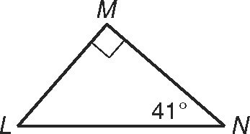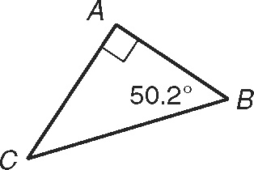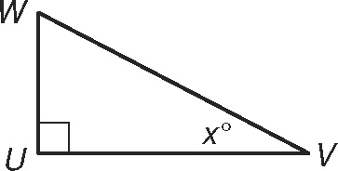
5. ∠L 6. ∠C 7. ∠W

Angle Relationships in Triangles continued
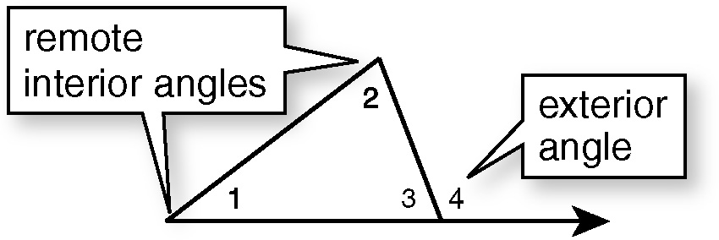
An exterior angle of a triangle is formed by
one side of the triangle and the extension of
an adjacent side.
∠1 and ∠2 are the remote interior angles of
∠4 because they are not adjacent to ∠4.
Exterior Angle Theorem
The measure of an exterior angle of a
triangle is equal to the sum of the
measures of its remote interior angles.

Third Angles Theorem
If two angles of one triangle are congruent
to two angles of another triangle, then
the third pair of angles are congruent.

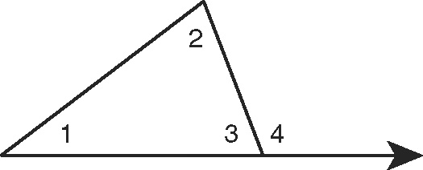
m∠4 = m∠1 1 m∠2

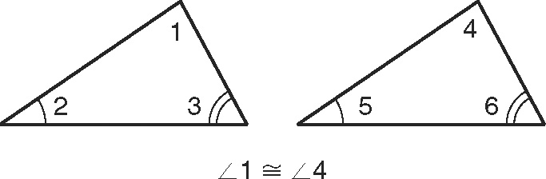

Find each angle measure.
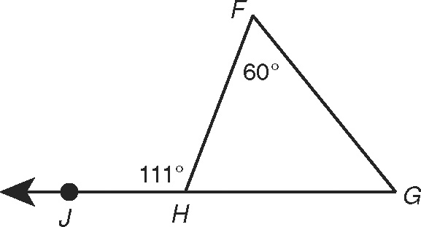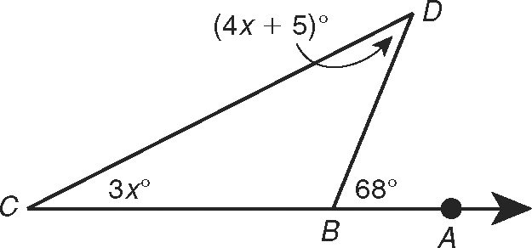
8. m∠G 9. m∠D

Find each angle measure.
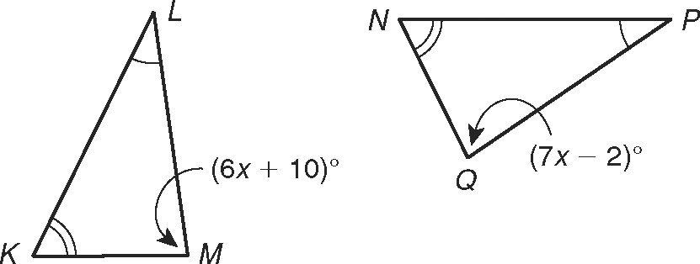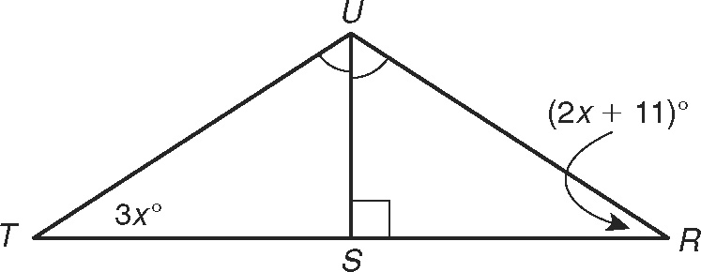
10. m∠M and m∠Q 11. m∠T and m∠R

