Compound Inequalities
Standard: SWABAT solve linear inequalities in one variable, including equations with coefficients of letters. ( MCC912.A.REI.3)

Name: ___________________________________ Mr. Murphey’s Coordinate Algebra
Date: 9/18/2013 Block: 2




Inbox Task – Solve 1-4
Solve each inequality.

- $x+ 3≤ 10$
- $23 <-2x + 3$

Solve each inequality and graph the solution.

- $4x + 1 ≤25$
- $0 ≥ 3x + 3$

Solving Compound Inequalities
Compound inequalities using AND require you to find solutions so that two inequalities will be satisfied at the same time.
Solve 2 < x + 3 ≤ 5 and graph the solutions.
The two inequalities are: 2 < x + 3 AND x + 3 ≤ 5.
Solve 2 < x + 3. Solve x + 3 ≤ 5.
2 < x + 3 x + 3 ≤ 5
−3 −3 Add −3 to both sides. −3 −3 Add −3 to both sides.

−1 < x x ≤ 2
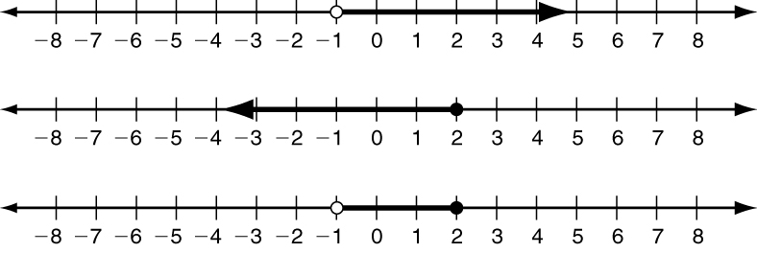
Graph x > −1.
Use overlapping regions for compound inequalities with AND.

Graph x ≤ 2.

Graph −1 < x ≤ 2.

Write the two inequalities that must be solved in order to solve each compound inequality.
1. −3 < x − 4 ≤ 10 ___________________________ AND ___________________________
2. 8 ≤ m + 4 ≤ 15 ___________________________ AND ___________________________
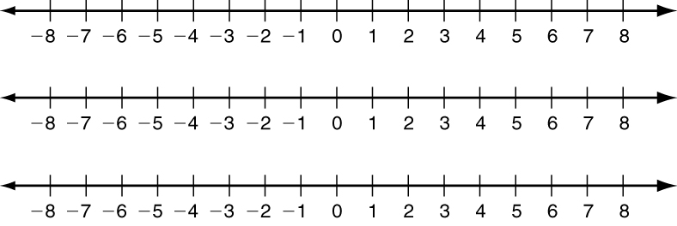
3. Graph −2 ≤ w < 6 by graphing each
inequality separately. Then graph the
compound inequality.

Solve each compound inequality and graph the solutions.
4. −5 < k − 1 < 0 5. −4 < 2x − 8 ≤ 6

Compound inequalities using OR require you to find solutions that satisfy either inequality.
Solve 4x > 12 OR 3x ≤ −15 and graph the solutions.
The two inequalities are: 4x > 12 OR 3x ≤ −15.
Solve 4x > 12. Solve 3x ≤ −15.
Divide both sides by 4. Divide both sides by 3.
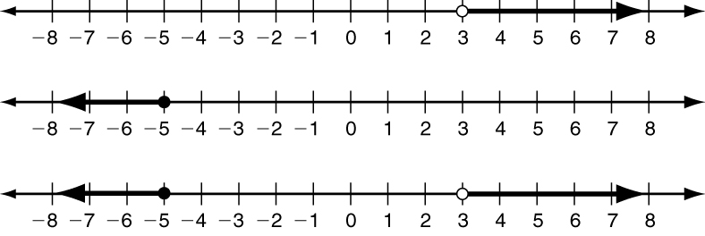
x > 3. x ≤ −5
Graph x > 3.
Use both regions for compound inequalities with OR.

Graph x ≤ −5.

Graph x > 3 OR x ≤ −5.
Write the compound inequality shown by each graph.
6. ___________________________________________

7. __________________________________________
8. Graph k ≤ −1 OR k > 4 by graphing
each inequality separately. Then
graph the compound inequality.

Solve each compound inequality and graph the solutions.
9. x + 2 ≥ 5 OR x + 6 < 2 10. 6b ≥ 42 OR 3b ≤ −3

Solving Compound Inequalities
Graph each inequality, and then graph the compound inequality.
1. x > −3 2. z < 0

x ≤ 4 z > 2

intersection: x > −3 AND x ≤ 4 union: z < 0 OR z > 2

Write the compound inequality shown by each graph.
3. 4.

Fill in the blanks to solve each compound inequality. Graph the solutions.
5. n + 5 < 2 OR n + 5 ≥ 9 6. −11 ≤ 2x − 1 ≤ 1
− _____ − _____ − _____ − _____ −11 ≤ 2x − 1 AND 2x − 1 ≤ 1
n < _____ OR n ≥ _____ + _____ + _____ + _____ + _____
_____ ≤ 2x AND 2x ≤ _____
÷ _____ ÷ _____ ÷ _____ ÷ _____
_____ ≤ x AND x ≤ _____
Write a compound inequality for each problem. Graph the solutions.

7. To relieve arthritis, Dr. Stoll recommends taking between 400 and 600 mg of ibuprofen, inclusive.
8. A part-time job says that the hourly rate is between $6.40 and $9.80 inclusive,
depending on experience.

