
Name: ___________________________________ Mr. Murphey’s Analytical Geometry
Date: 2/18/2014 Block: 2
Standard: SWABAT explain how the criteria for triangle congruence follow the definition of congruence in terms of rigid motions. (MCC912.G.CO.8)

$∆ ≅$ ASA, AAS, and HL
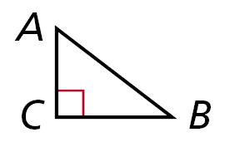

Inbox Task –
1. What are sides AC and BC called? Side AB?

2. Which side is in between ∠A and ∠C?
3. Given ΔDEF and ΔGHI, if ∠D ≅ ∠G and ∠E ≅ ∠H, why is ∠F ≅ ∠I?
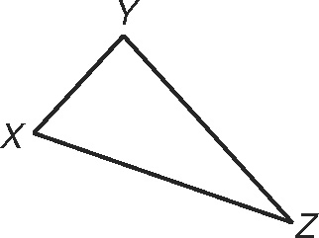
Triangle Congruence: ASA, AAS, and HL
Name the included side for each pair of
consecutive angles.
1. ∠X and ∠Z ________ 2. ∠Y and ∠X ________
3. ∠Y and ∠Z ________

Write ASA (Angle-Side-Angle Congruence), AAS (Angle-Angle-Side Congruence),
or HL (Hypotenuse-Leg Congruence) next to the correct postulate.
4. If the hypotenuse and a leg of one right triangle are congruent to the hypotenuse
and a leg of another right triangle, then the triangles are congruent. _________
5. If two angles and a nonincluded side of one triangle are congruent to the corresponding angles and nonincluded side of another triangle, then the triangles are congruent. _________
6. If two angles and the included side of one triangle are congruent to two angles
and the included side of another triangle, then the triangles are congruent. _________

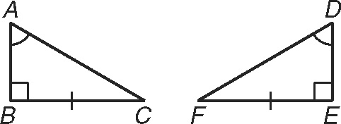
For Exercises 7–9, tell whether you can use each congruence theorem to prove that ABC > DEF.
If not, tell what else you need to know.
7. Hypotenuse-Leg _________________________________________________

8. Angle-Side-Angle _________________________________________________

9. Angle-Angle-Side _________________________________________________

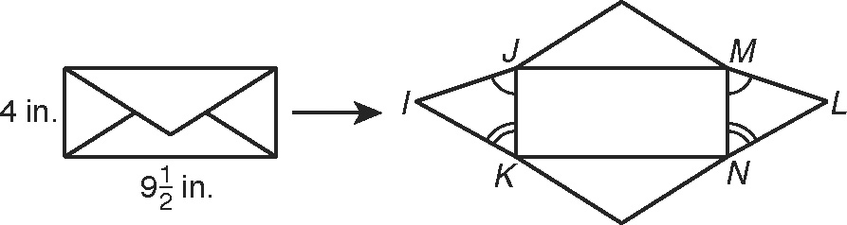
10. A standard letter-sized envelope is a $9\frac{1}{2}$ –in-by-4-in. rectangle. The envelope is folded
and glued from a sheet of paper shaped
like the figure. Use the phrases in the
word bank to complete this proof.
Given,
ASA,
Definition of rectangle

Given: JMNK is a rectangle. ∠IJK > ∠LMN, ∠IKJ > ∠LNM
Prove: IJK > LMN
Statements | Reasons
1. ∠IJK > ∠LMN, ∠IKJ > ∠LNM | 1. a.
2. | 2. b.
3. IJK > LMN | 3. c.
Triangle Congruence: ASA, AAS, and HL
Students in Mrs. Marquez’s class are watching a film on the uses of geometry in architecture. The film projector casts the image on a flat screen as shown in the figure. The dotted line is the bisector of ∠ABC. Tell whether you can use each congruence theorem to prove that ABD $≅$ CBD. If not, tell what else you need to know.
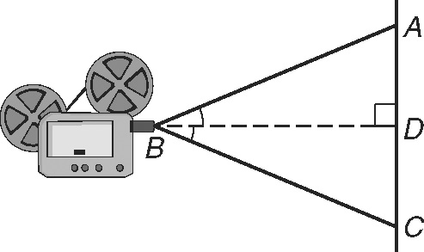
1. Hypotenuse-Leg ____________________________________________________________
2. Angle-Side-Angle ____________________________________________________________
3. Angle-Angle-Side ____________________________________________________________
Write which postulate, if any, can be used to prove the pair of triangles congruent.
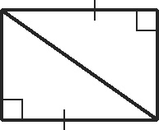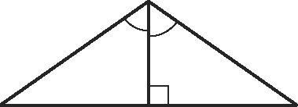
4. ______________________ 5. ______________________
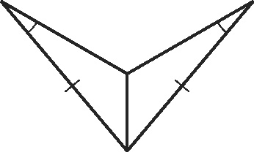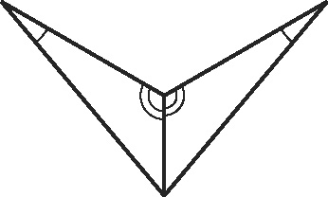
6. ______________________ 7. ______________________
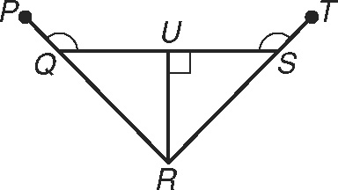
Write a paragraph proof.
8. Given: ∠PQU > ∠TSU,
∠QUR and ∠SUR are right angles.
Prove: RUQ > RUS

Use the following information for Exercises 1 and 2.
Melanie is at hole 6 on a miniature golf course. She
walks east 7.5 meters to hole 7. She then faces south,
turns 67° west, and walks to hole 8. From hole 8, she
faces north, turns 35° west, and walks to hole 6.
1. Draw the section of the golf course described.
Label the measures of the angles in the triangle.
2. Is there enough information given to determine the location of holes
6, 7, and 8? Explain.

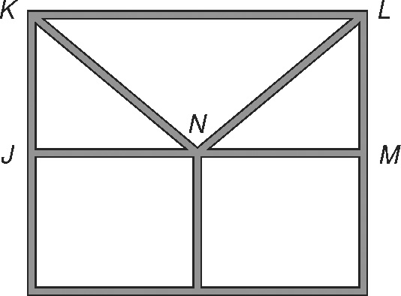
3. A section of the front of an English Tudor home is shown in
the diagram. If you know that and
can you use HL to conclude that JKN > MLN? Explain.

