Solving Linear Inequalities
Standard: SWABAT Graph the solutions to a linear inequality in two variables as a halfplane (MCC912.A.REI.12)

Name: ___________________________________ Mr. Murphey’s Coordinate Algebra
Date: 2/25/2014 Block: 1 4



Inbox Task – Graph each inequality.
- x > –5 2(x + 1) = 2x + 2
- y ≤ 0

Solve by using any method.

- Write –6x + 2y = –4 in slope-intercept form, and graph.

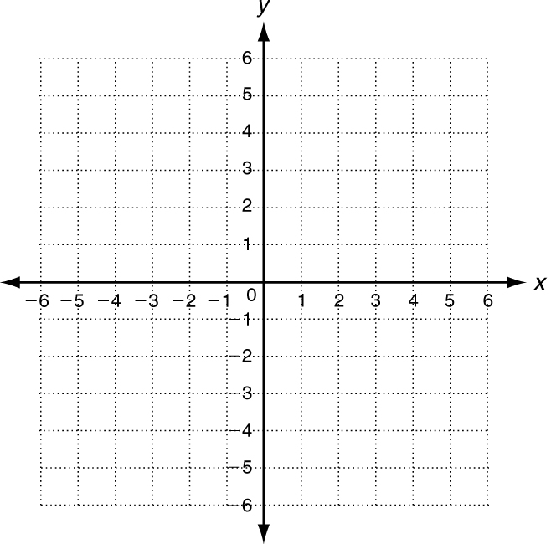
Solving Linear Inequalities
Tell whether the ordered pair is a solution of the given inequality.
1. (1, 6); y < x + 6 2. (−3, −12); y ≥ 2x − 5 3. (5, −3); y ≤ −x + 2

Graph the solutions of each linear inequality.
4. y ≤ x + 4 5. 2x + y > −2 6. x + y − 1 < 0
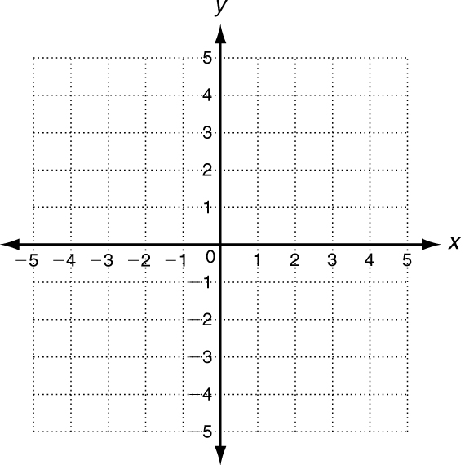

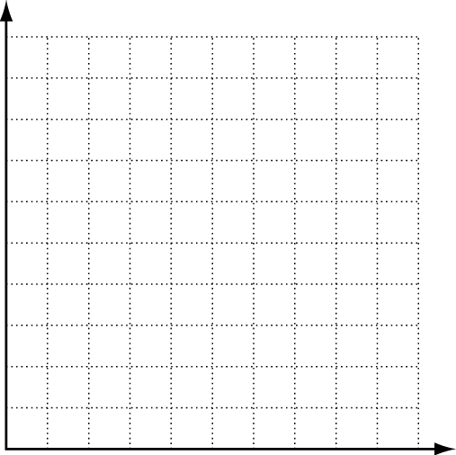
7. Clark is having a party at his house. His father has allowed him to spend at most $20 on snack food. He’d like to buy chips that cost $4 per bag, and pretzels that cost $2 per bag.
a. Write an inequality to describe the situation.
______________________________________________________b.Graph the solutions.
c. Give two possible combinations of bags of chips and pretzels
___________________________________________________
___________________________________________________
Write an inequality to represent each graph.
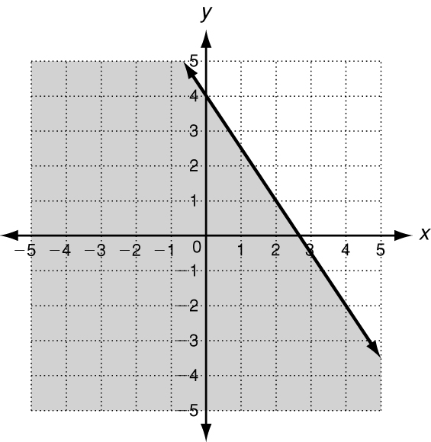
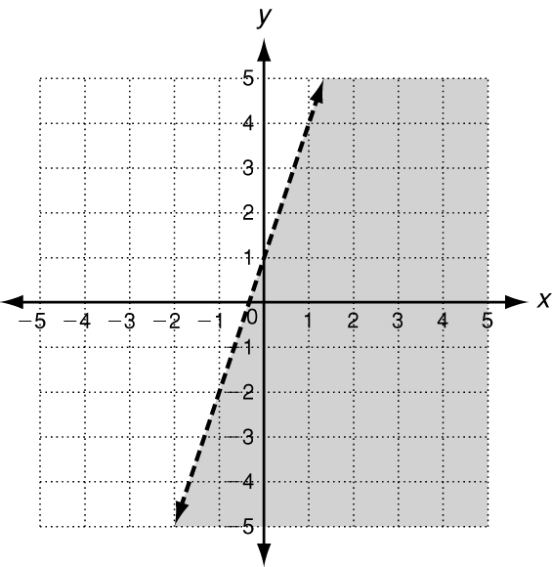
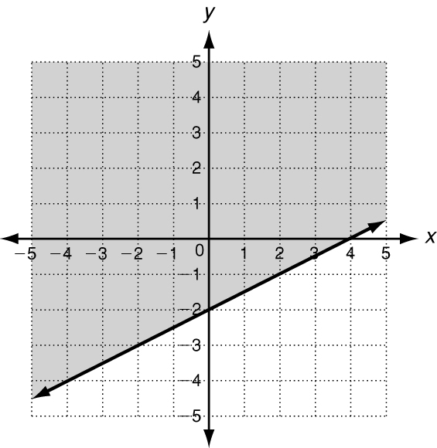
8. 9. 10.

Graph the solutions of each linear inequality.
11. y ≤ x + 2 12. −3x < y 13. 2x − y − 4 > 0

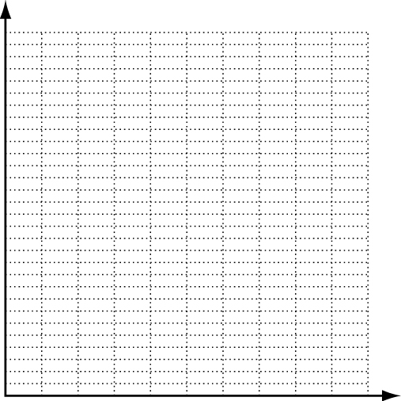
14. Adam is ordering helium balloons for his sister’s birthday. He has up to $15 to spend. Decorative balloons cost $3.00 each and solid colored balloons cost $0.50 each.
a. Write an inequality to describe the situation.
______________________________________________________
b. Graph the solutions.
c. Give two possible combinations of decorative
and solid colored balloons Adam can order.
___________________________________________________
___________________________________________________

Write an inequality to represent each graph.
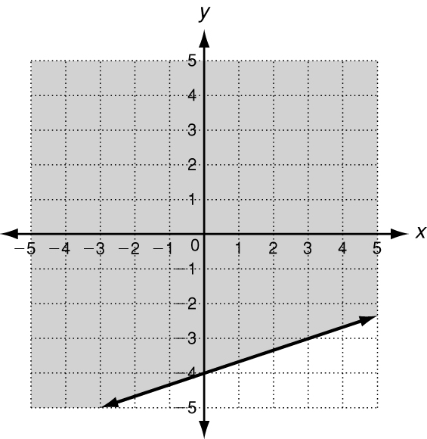
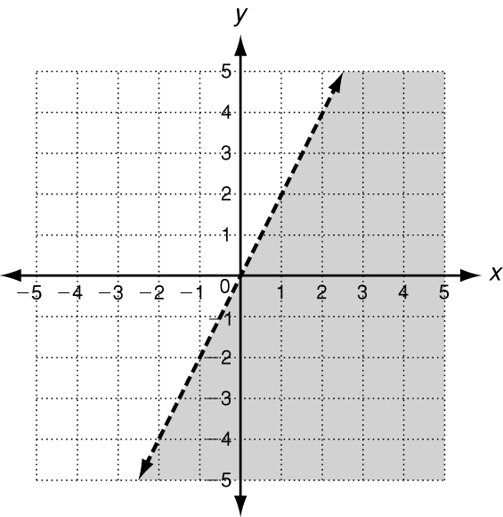
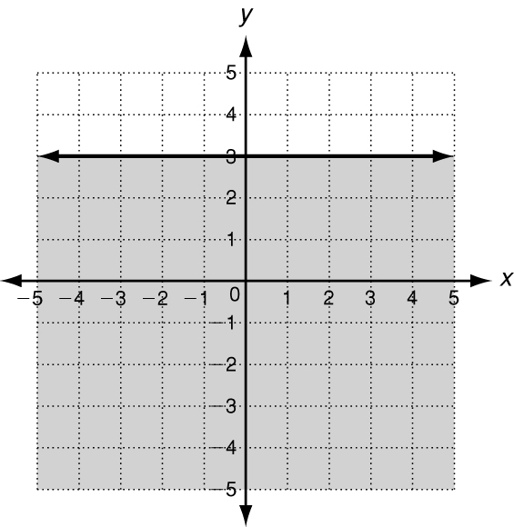
15. 16. 17.

Solving Linear Inequalities
Write the correct answer.

18. Shania would like to give $5 gift cards and $4 teddy bears as party favors. Sixteen people have been invited to the party. Shania has $100 to spend on party favors. Write and graph an inequality to find the number of gift cards x and teddy bears y Shania could purchase.
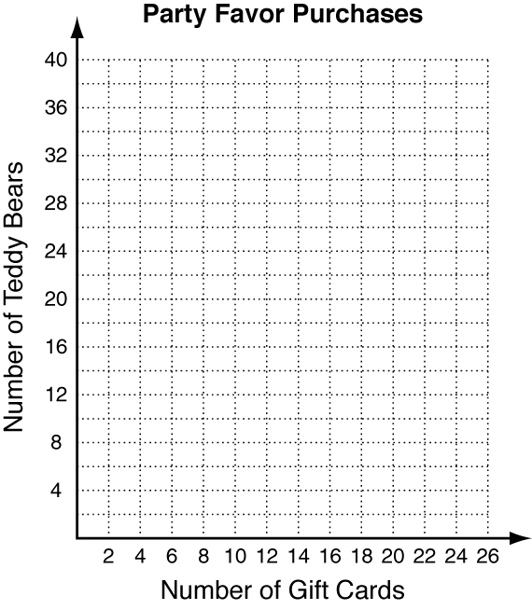
19. Hank has 20 yards of lumber that he can use to build a raised garden. Write and graph a linear inequality that describes the possible lengths and widths of the garden. If Hank wants the dimensions to be whole numbers only, what dimensions would produce the largest area?
