Unit 2 Review
Standard: SWABAT Graph the solutions to a linear inequality in two variables as a halfplane (MCC912.A.REI.12)

Name: ___________________________________ Mr. Murphey’s Coordinate Algebra
Date: 2/27/2014 Block: 1 4


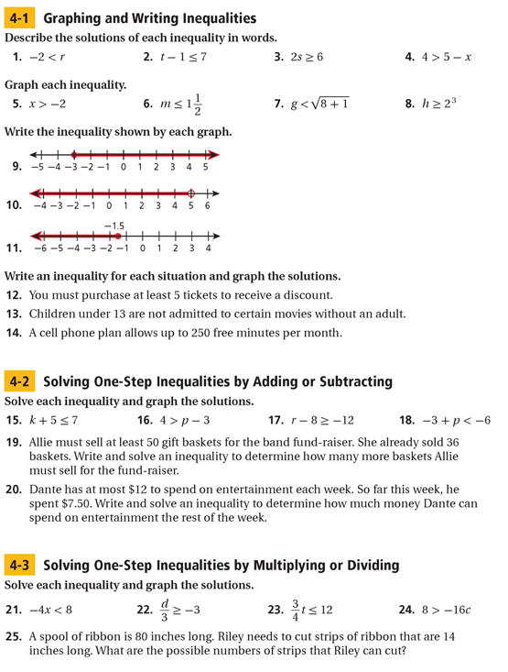

Inbox Task – Complete the Following on Pg. 64-69
