Graphing Inequalities
Standard: SWABAT Graph the solutions to a linear inequality in two variables as a halfplane (MCC912.A.REI.12)

Name: ___________________________________ Mr. Murphey’s Coordinate Algebra Support
Date: 10/1/2013 Block: 1 4




Inbox Task – Solve 1-3 – Graph each inequality.
1. $x >- 5$ 2. $y≤0$ 3. Write -$6x + 2y = -4$
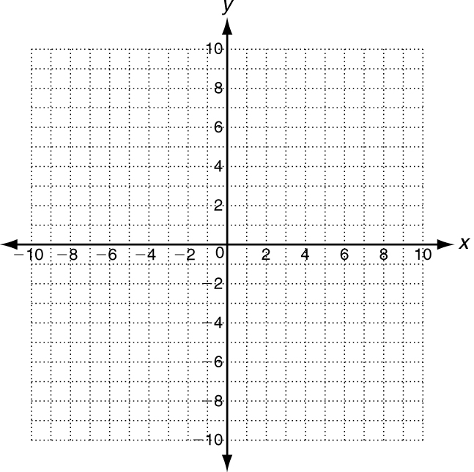
in slope-intercept form, and graph.

Solving Linear Inequalities
When graphing an equation, the solutions are all the points on the line. When graphing an inequality, the solutions are all the points above or below the line (and may include the line).
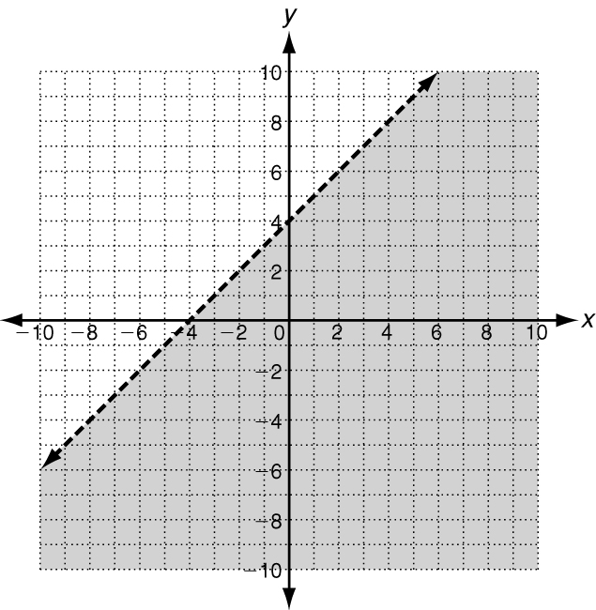
Graph y = x + 4. Graph y < x + 4.
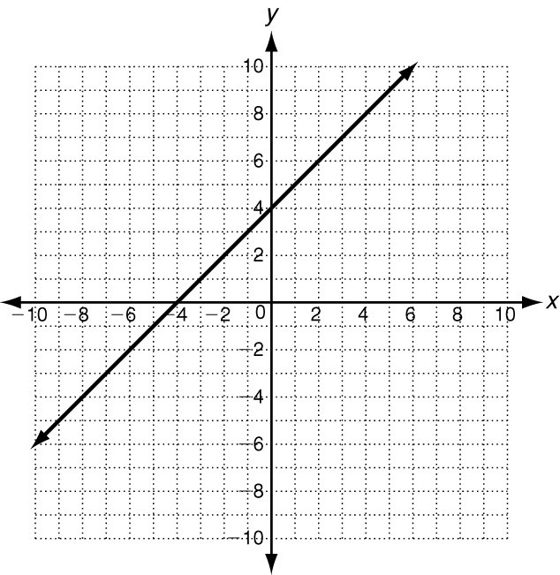
Solutions are everywhere below the line. Because the line is dashed, the solutions are not on the line.

Solutions are
only on the
line.

One method of determining which side to shade is to choose a point anywhere on the graph (except on the line). Then substitute to determine if it makes the inequality true.
The boundary line for the inequality y > −x + 5 is graphed below. Shade the correct side.
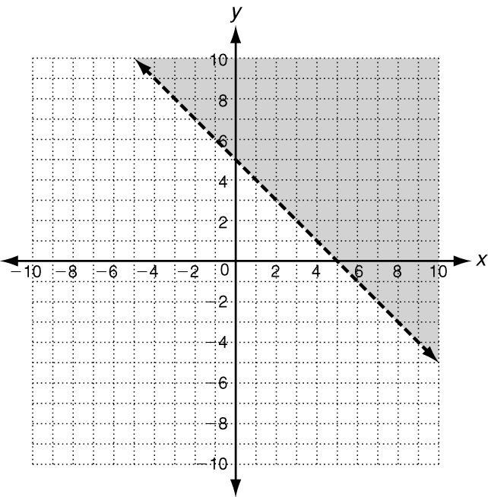
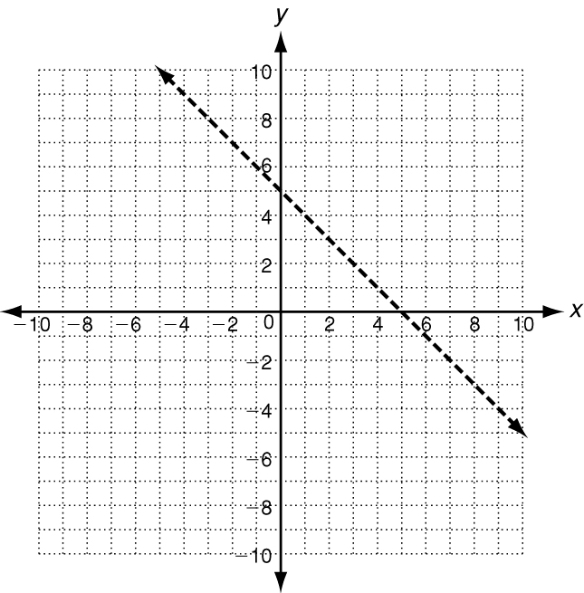
Step 1: Choose a point.
Step 2: Substitute (0, 0) in the inequality y > −x + 5.
y > −x + 5
0 ? > −0 + 5
0 ? > 5
The statement is false.
Step 3: Because (0, 0),
which is below the line, resulted in a false statement, it is not a solution. Shade above the line.

The point (0, 0) is an easy point to check.

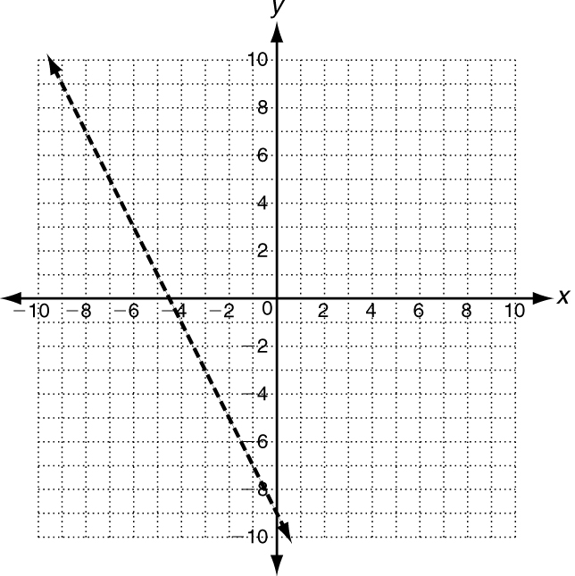
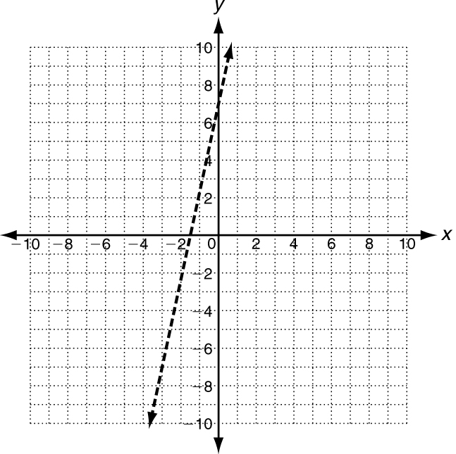
The boundary lines for each inequality are graphed below. Shade the correct side
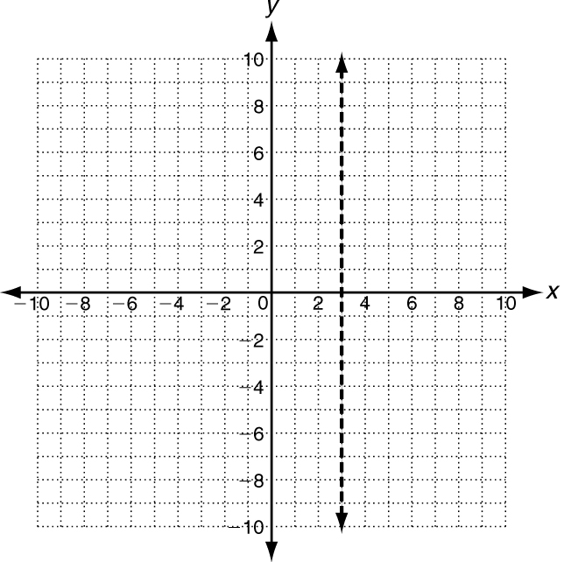
1. y > 5x + 7 2. y < −2x − 9 3. x > 3

To graph a linear inequality:
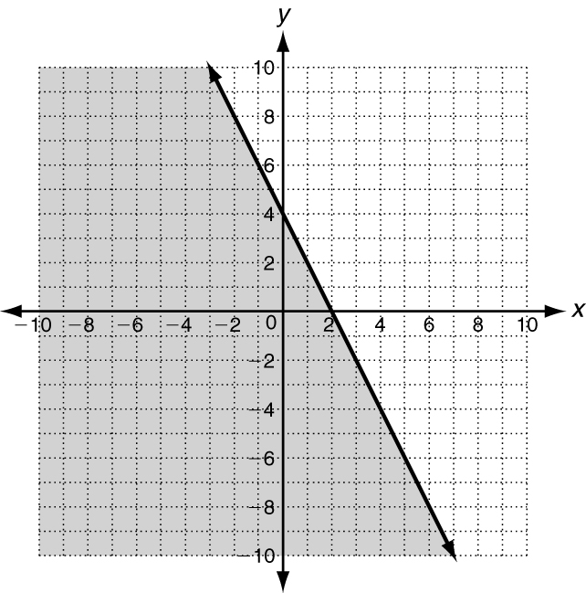
Step 1: Solve the inequality for y.
Step 2: Graph the boundary line. If ≤, or ≥ use a solid line. If < or > use a dashed line.
Step 3: Determine which side to shade.
Graph the solutions of 2x + y ≤ 4.
Step 1: Solve for y. 2x + y ≤ 4
−2x −2x
y ≤ −2x + 4
Step 2: Graph the boundary line.
Use a solid line for ≤.
Step 3: Determine which side to shade.
Substitute (0, 0) into 2x + y ≤ 4.
2x + y ≤ 4
2(0) + 0 ?≤ 4
0 ? ≤ 4. The statement is true. Shade the side that contains the point (0, 0).
Graph the solutions of each linear inequality.
4. y − x < 3 5. x + y + 2 ≥ 0

Use substitution to tell whether the ordered pair is a solution of the given inequality.
1. (3, 4); y > x + 2 2. (4, 2); y ≤ 2x − 3 3. (2, −1); y < −x

Rewrite each linear inequality in slope-intercept form. Then graph the solutions in the coordinate plane.
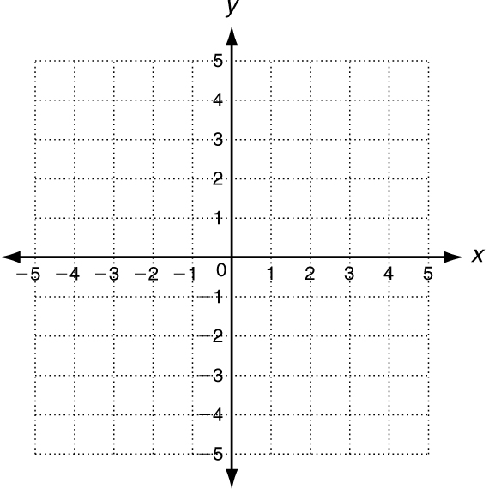
4. y − x ≤ 3 5. 6x + 2y > −2

_________________ _________________

6. Trey is buying peach and blueberry yogurt cups. He will buy at most 8 cups of yogurt. Let x be the number of peach yogurt cups and y be the number of blueberry yogurt cups he buys.
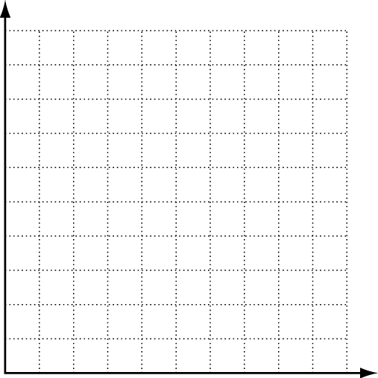
a. Write an inequality to describe the situation.
b. Graph the solutions.
c. Give two possible combinations of peach
and blueberry yogurt that Trey can choose.
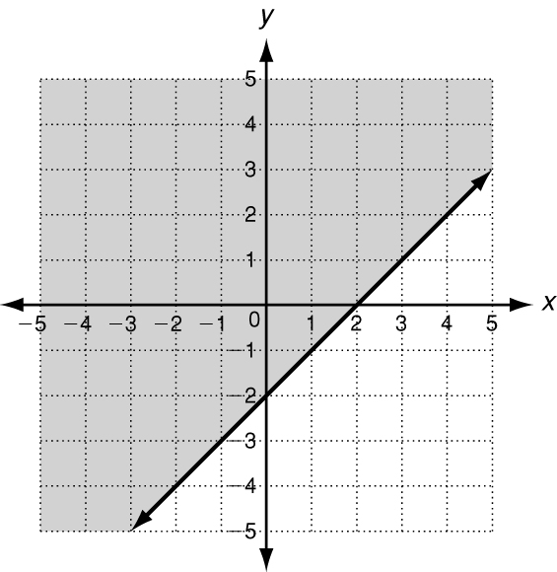
Write an inequality to represent each graph.
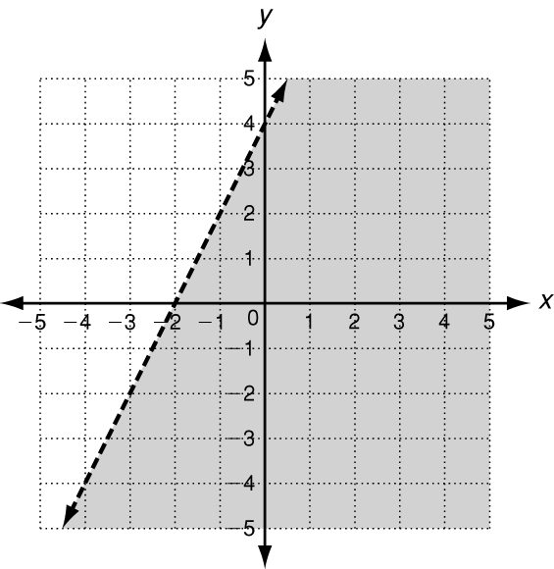
7. 8.

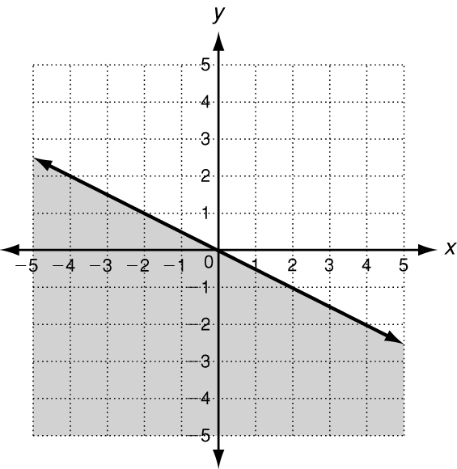
7. 9.

