Relations ahd Functions
Standard: SWABAT Understand that a function assigns to each element of the domain exactly one of the range (MCC912.F.IF.1)

Name: ___________________________________ Mr. Murphey’s Coordinate Algebra Support
Date: 10/4/2013 Block: 1 4


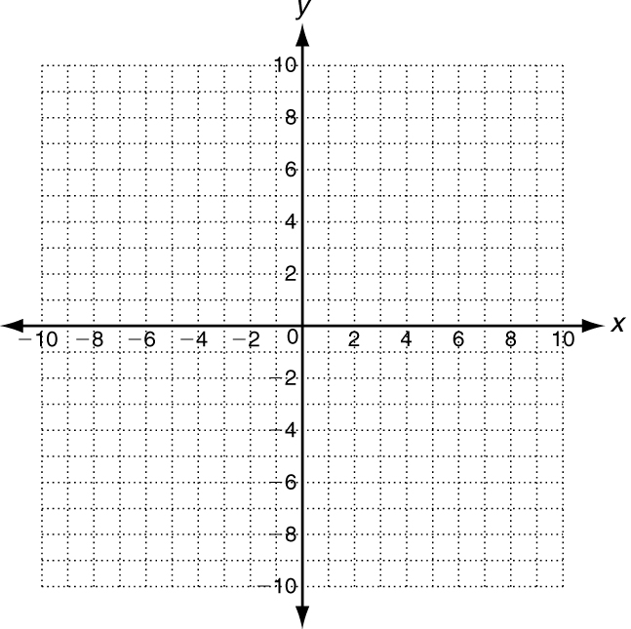


Inbox Task – Solve 1-6 – State whether each word or phrase represents an amount
that is increasing, decreasing, or constant.
1. stays the same 2. rises 3. drops 4. slows down

5. Generate ordered pairs for the function $y= x +3$ for x = -2, -1, 0, 1, and 6.
6. Graph the ordered pairs.
Graphing Relationships Explanation
Graphs are a way to turn words into pictures. Be sure to read the graphs from left to right.
increasing decreasing stays the same
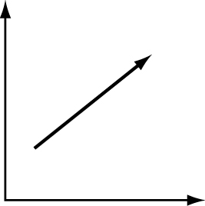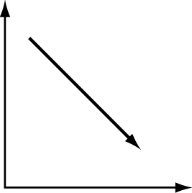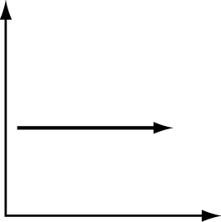
Other descriptions: Other descriptions: Other descriptions:
rose gained grew fell lessened diminished constant steady continuous
You can divide the graph into sections every time the graph changes directions. Then label each section.
Picture Words
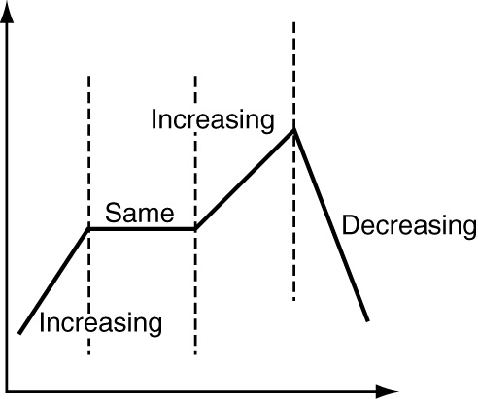
This graph increases, then stays constant,
increases again, and finally decreases sharply.

Divide each graph into sections. Then label the sections as increasing, decreasing, or same.
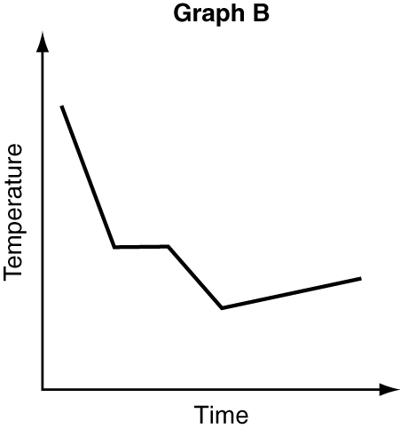
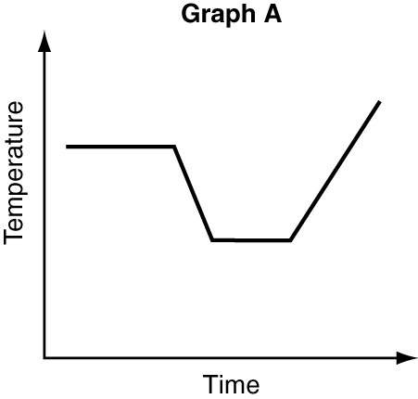
1.. 2.

3. Which graph above shows that the air temperature
fell steadily, leveled off, fell again, and then
increased slightly? _____________________________________

A graph can be continuous or discrete. Continuous means the situation can include fractions or decimals. Discrete means the situation must have only specific amounts.
Continuous Discrete
time, temperature, distance people, animals, objects
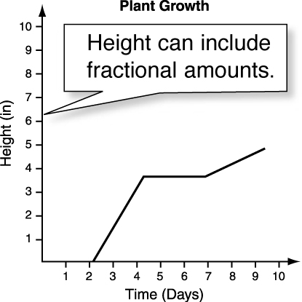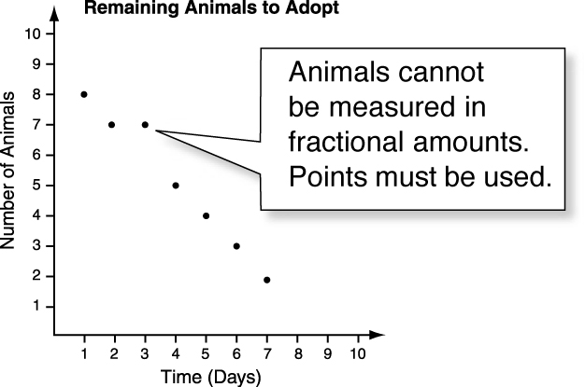
Sketch a graph of each situation. Tell whether the graph is continuous or discrete.

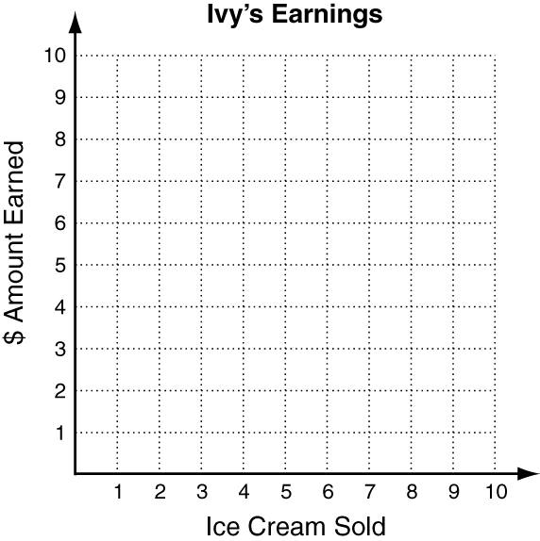
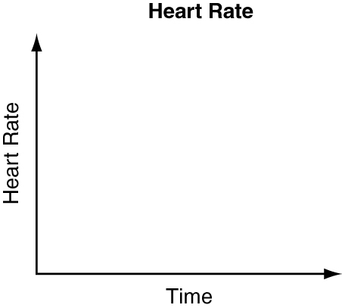
4. The heart rate of someone walking, then running,
then resting.

5. Ivy is selling ice cream. Each ice cream costs $1.50.She has 6 ice creams to sell.

Graphing Relationships
For each, write if the height is rising, falling, or staying the same.
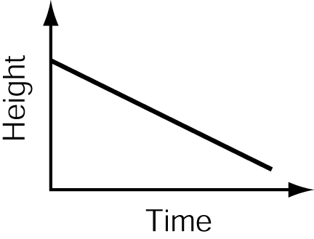
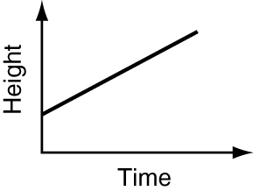
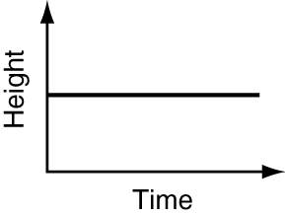
1. 2. 3.

Choose the graph that best represents each situation.
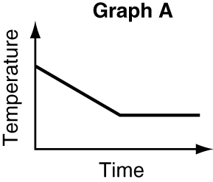
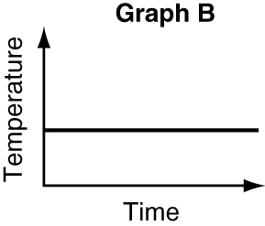
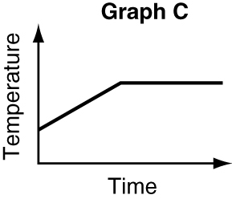

4. The temperature of the water in a glass
remained constant. _____________________________________
5. The temperature of the water in a glass rose
steadily for several hours until it reached room
temperature, then remained constant. _____________________________________
6. The temperature of the water in a glass cooled
down steadily with the addition of ice, then
remained constant when all the ice had melted. _____________________________________
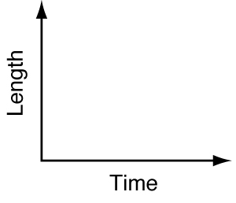
7. Don’s hair grows steadily longer between haircuts. Sketch a
graph to show the length of Don’s hair between two haircuts.
Is the graph continuous or discrete?

Write a possible situation for the graph.
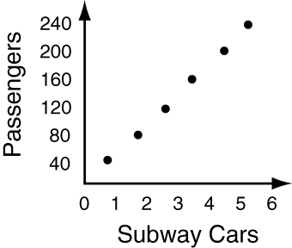
8.

____________________________________________________
____________________________________________________
____________________________________________________

Relations and Functions Explanation
A relation is a set of ordered pairs. The relation can be in the form of a table, graph,
or mapping diagram. The domain is all the x-values. The range is all the y-values.
Find the domain and range. Find the domain and range.
x | 3 | 4 | 5 | 6
y | 1 | 2 | 2 | 3
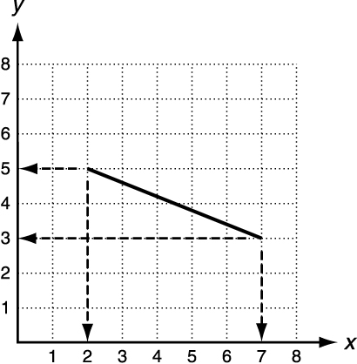
Do not list 2 twice in the range.

D: {3, 4, 5, 6}; R: {1, 2, 3}

Find the domain and range.
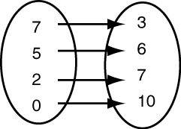

range: from
3 to 5

D: {7, 5, 2, 0}; R: {3, 6, 7, 10} D: 2 ≤ x ≤ 7
R: 3 ≤ y ≤ 5
domain: from 2 to 7
Find the domain and range of each relation.
1. 2. (4, 5) (−2, 6) (−5, 12)
x | −2 | −1 | 0 | 1
y | 4 | 1 | 0 | 4

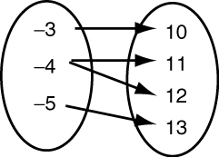
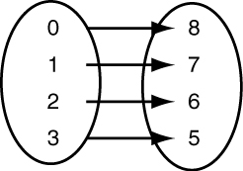
3. 4.

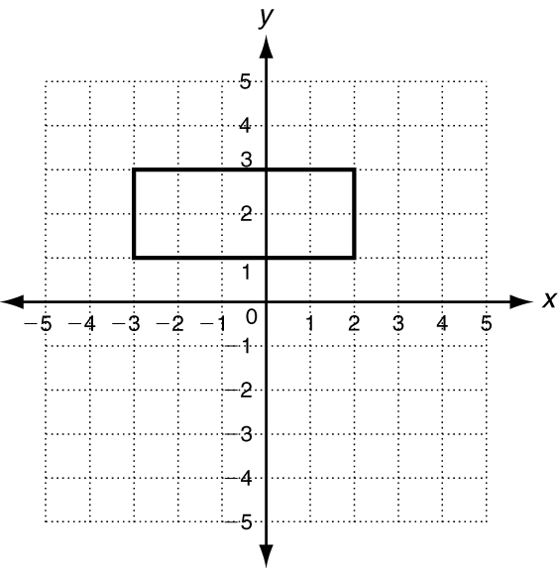
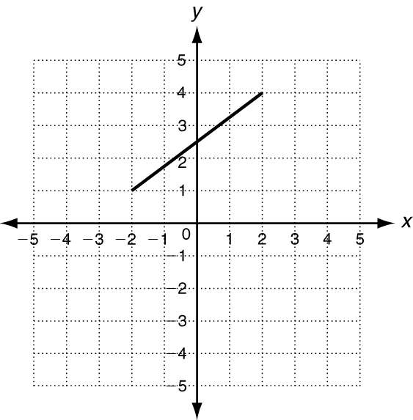
5. 6.

A function is a type of relation where each x value (domain) can be paired with only one y value (range).
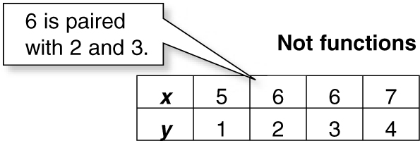
Functions Not functions
x | 2 | 3 | 4 | 5
y | 3 | 4 | 4 | 6

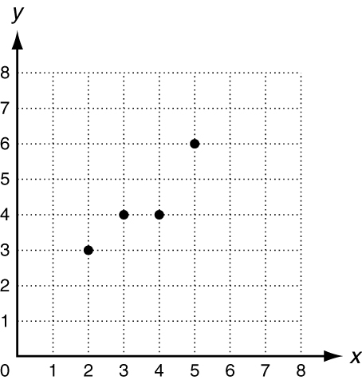
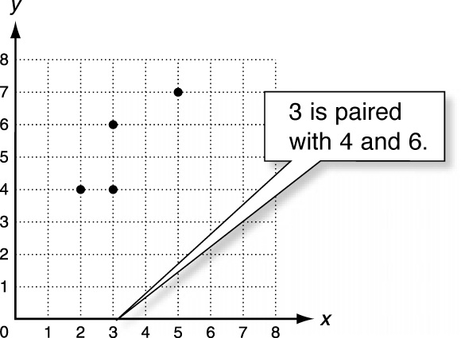

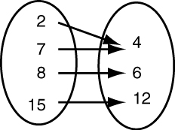
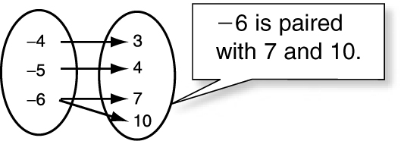

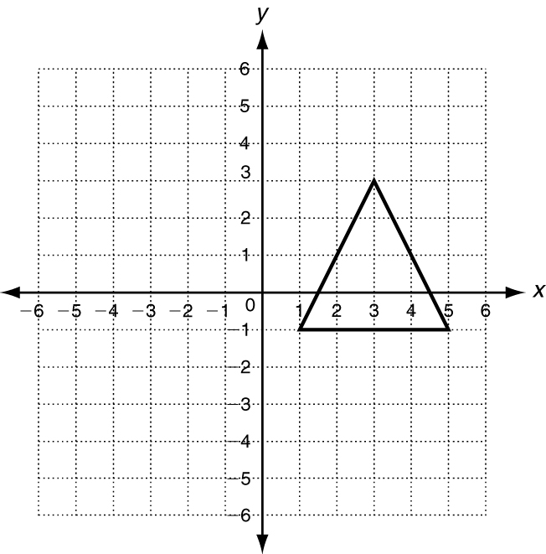
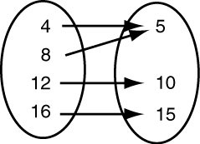
Tell whether the relation is a function. Explain.
7. 8. 9.
x | −2 | −3 | −3 | −4
y | 1 | 2 | 3 | 4

Express each relation as a table, as a graph, and as a mapping diagram.
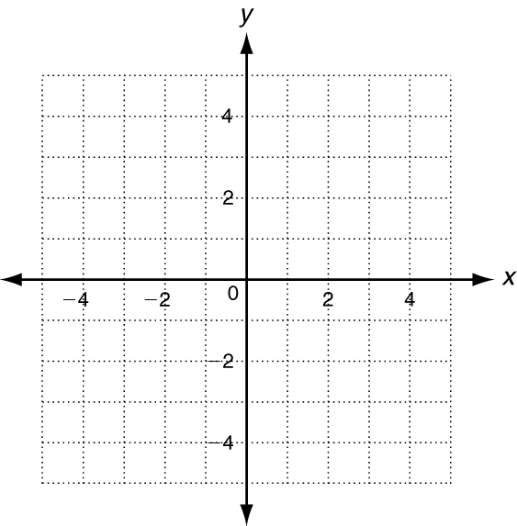
1. {(−2, 5), (−1, 1), (3, 1), (−1, −2)}
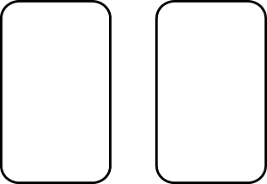
x | y

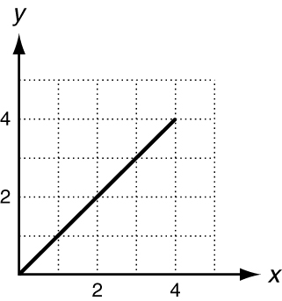
Give the domain and range of each relation. Tell whether the relation is a function. Explain.
x | y
1 | 4
2 | 5
0 | 6
1 | 7
2 | 8
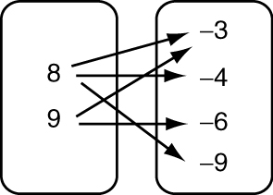
3. 4. 5.

D: ____________________ D: ____________________ D: ____________________
R: ____________________ R: ____________________ R: ____________________
Function? ______________ Function? _____________ Function? _____________
Explain: ______________ Explain: ______________ Explain: _____________

