Relations & Functions
Standard: SWABAT Graph the solutions to a linear inequality in two variables as a halfplane (MCC912.A.REI.12)

Name: ___________________________________ Mr. Murphey’s Coordinate Algebra
Date: 3/4/2014 Block: 1 4



Inbox Task – Generate ordered pairs for the function

y = x + 3 for x = –2, –1, 0, 1, and 2. Graph the
ordered pairs.

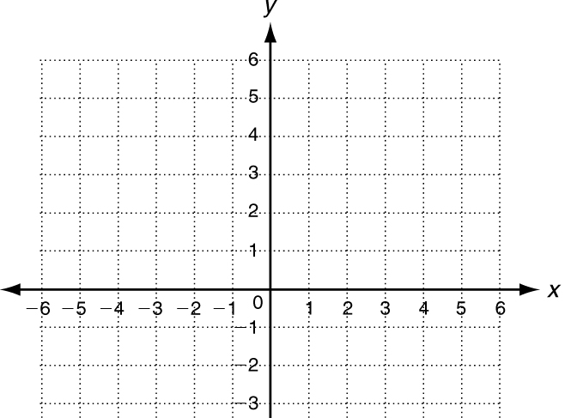
Relations and Functions
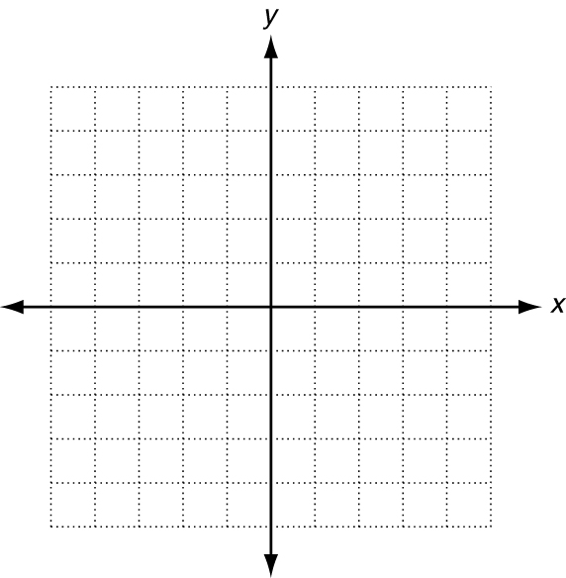
Express each relation as a table, as a graph, and as a mapping diagram.
1. {(−3, 5), (−2, 4), (−1, 1), (−1, −3)}
x |   y
2. {(−2, 0), (−2, 1), (−2, 2), (−2, 3), (−2, 4), (−2, 5)}
x | y
Give the domain and range of each relation. Tell whether the relation is a function. Explain.
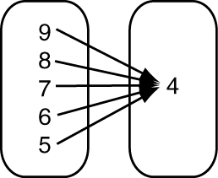
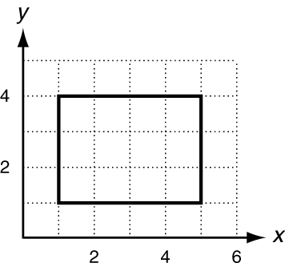
3. 4. 5.
x | y
1 | 1
2 | 2
3 | 3
4 | 4
5 | 5

D: ____________________ D: ____________________ D: ____________________
R: ____________________ R: ____________________ R: ____________________
Function? ______________ Function? _____________ Function? _____________
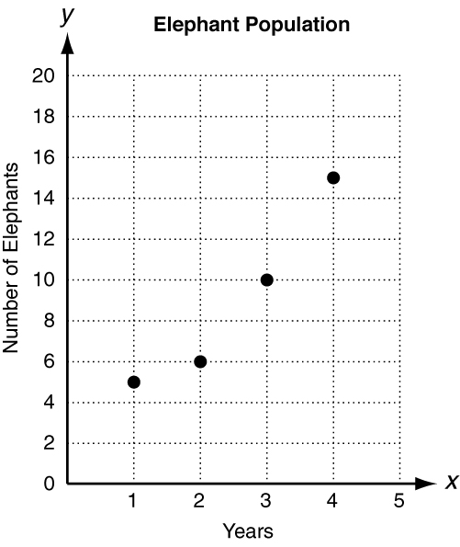
Explain: ______________ Explain: ______________ Explain:

Use the graph below to answer questions 5–6. A conservation group has been
Working to increase the population of a herd of Asian elephants. The graph
shows the results of their efforts. Select the correct answer.
6. Which relation represents the information in the graph?
A {(1, 4.5), (2, 6), (3, 10), (4, 14.5)} B{(1, 5), (2, 6), (3, 10), (4, 15)}
C {(4.5, 1), (6, 2), (10, 3), (14.5, 4)} D{(5, 1), (6, 2), (10, 3), (15, 4)}
7. What is the range of the relation shown in the graph?

