Write & Graph Functions
Standard: SWABAT use function notation, evaluate functions for inputs in their domains, and interpret statements. (MCC912.F.IF.2)

Name: ___________________________________ Mr. Murphey’s Coordinate Algebra Date: 10/7/2013 Block: 2




Inbox Task – Solve 1-5 – Evaluate each expression for a = 2, b = –3, and c = 8.

- $a + 3c$

- $ab – c$
- $\frac{1}{2}c+b$

- $4c+b$
- $b^{a}+c$

Rewrite each sentence using the word depends. Then identify the dependent and the independent variables.
1. A very large animal will eat many pounds of food.

Dependent: _____________________________ Independent: ______________________________
2. The fire was very large, so many firefighters were there.

Dependent: _____________________________ Independent: ______________________________
3. The temperature of the water on the heated stove rose each minute.

Dependent: _____________________________ Independent: ______________________________
4. The restaurant bill was low because only a few meals were ordered.

Dependent: _____________________________ Independent: ______________________________
Identify the dependent and the independent variables for each situation below. Write the function. Then evaluate the function for the given input values.
5. A limo service charges $90 for each hour.

Dependent f(x): ________________________
Independent x: ________________________
Function: ________________________
Evaluate for x = 2.

____________________
Evaluate for x = 7.5.

____________________
6. A computer support company charges $295 for the first hour plus $95 for each additional hour.
Dependent f(x): ________________________
Independent x: ________________________
Function: ________________________
Evaluate for x = 3.25.

____________________
Evaluate for x = 8.

____________________

Writing Functions
Choose the equation from the box that describes each relationship.
y = −3x
y = 3x
y = x − 3
1.
x | −3 | −2 | −1 | 0
y | −9 | −6 | −3 | 0

2. {(3, 0), (2, −1), (1, −2), (0, −3)}
3. {(0, 0), (1, −3), (2, −6), (3, −9)}
For each, write whether the given variable is independent or dependent.
4. Auto insurance costs increase with each accident and traffic violation.
• number of accidents/violations: ___________________________________________________
• cost of auto insurance: ___________________________________________________________
5. Christian is buying several DVDs that cost $12 each.
• total cost of the DVDs: ___________________________________________________________
• number of DVDs purchased: _____________________________________________________
Evaluate each function for the given input values.
6. For f(x) = x + 7, find f(x) when x = 3 and when x = −5. _________________ ________________
7. For g(x) = −2x, find g(x) when x = 4 and when x = −1. _________________ ________________
8. For h(x) = 3x − 1, find h(x) when x = −2 and when x = 7. _________________ ________________
Complete the following.
9. Marlena is making her own beaded bracelets. rule: ________________________________
Each bracelet will have 10 beads. Write a function
rule to describe the number of beads she will use. domain: ____________________________
Find a reasonable domain and range for the function
if Marlena makes up to 7 bracelets. range: ______________________________

10. Giselle is going to rent a scooter for at least one rule: ______________________________
hour. The fee is $45 plus $5 for each hour it is
rented. Write a function rule to describe the total domain: ___________________________
cost of renting a scooter. Find a reasonable domain
and range for the function if Giselle has $65. range: ____________________________

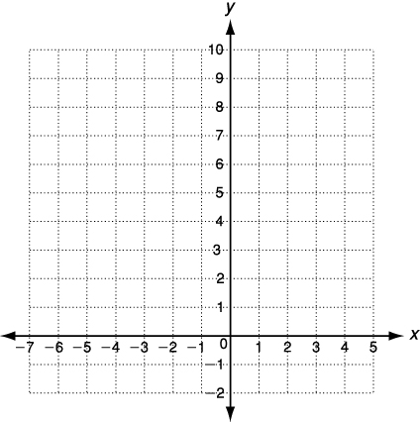
Graph each function.
1. y = (x + 2)²
x | y = (x + 2)² | (x, y)
−4 | y = (−4 + 2)² = (−2)² = _____
−3 | y = (−3 + 2)² = (_____)² = _____
−2 | y = (_____ + 2)² = (_____)² = _____
−1 | y = (_________)² = (_____)² = _____
0 | y = ______________________________
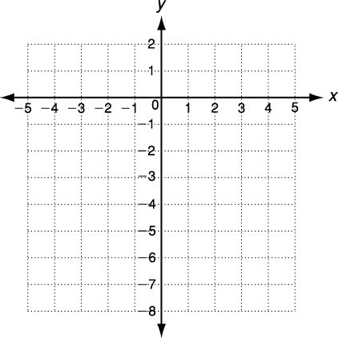
2. f(x) = x − 3
x | y = x − 3 | (x, y)
 |  | 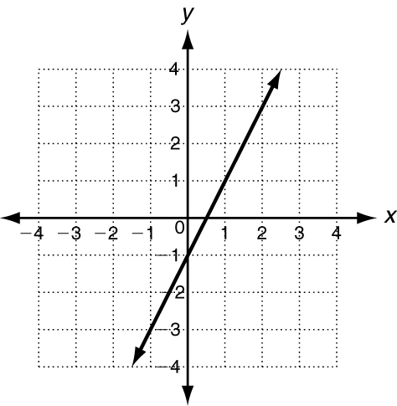

Use this graph of f(x) = 2x − 1 to find these
values.
3. f(x) = ______ when x = −1
4. f(x) = ______ when x = 1
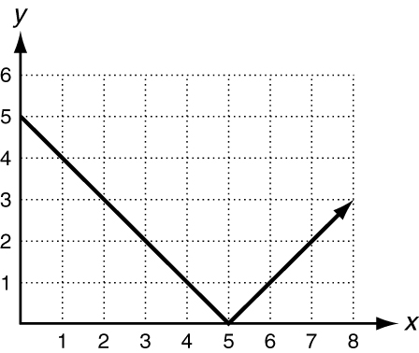
5. f(x) = ______ when x =

Use this graph of f(x) = |5 − x| to find these values.
6. f(x) = ______ when x = 2
7. f(x) = ______ when x = 6
8. x = ______ when f(x) = 0

