Writing Functions
Functions have dependent and independent variables. The dependent variable will always depend on the independent variable.
Rewrite each situation using the word depends. Then identify the dependent and the independent variables.
An employee who works longer hours will receive a larger amount in her paycheck.
Rewrite sentence:
The amount of a paycheck depends on the number of hours worked.
Dependent: amount of paycheck Independent: number of hours worked
A box with several books weighs more than a box with just a few books.
Rewrite sentence:
The weight of a box depends on the number of books in the box.
Dependent: weight of box Independent: number of books in box

After identifying the independent and dependent variables, you can write a rule in function notation. Remember that f(x) is the dependent variable and x is the independent variable.
Identify the dependent and independent variables. Write a function rule for each situation.
A zoo charges $6 for parking and $17.50 for each child.
1. Identify the dependent and independent variables.
The cost of admission depends on the number of children.
Dependent f(x): cost of admission Independent x: number of children
2. Write the equation in words.
The cost of admission is $17.50 multiplied by the number of children plus $6 for parking.
3. Write the function using cost of admission = f(x) and number of children = x.
f(x) = $17.50x + $6.00
Evaluate the function above when x = 4 and x = 10.
x = 4 x = 10
f(x) = $17.50x + $6.00 f(x) = $17.50x + $6.00
f(4) = $17.50(4) + $6.00 f(10) = $17.50(10) + $6.00
= $70.00 + $6.00 = $175.00 + $6.00
= $76.00 = $181.00

Graphing Functions
There are three steps to graphing a function.
Graph f(x) = |x| + 2.
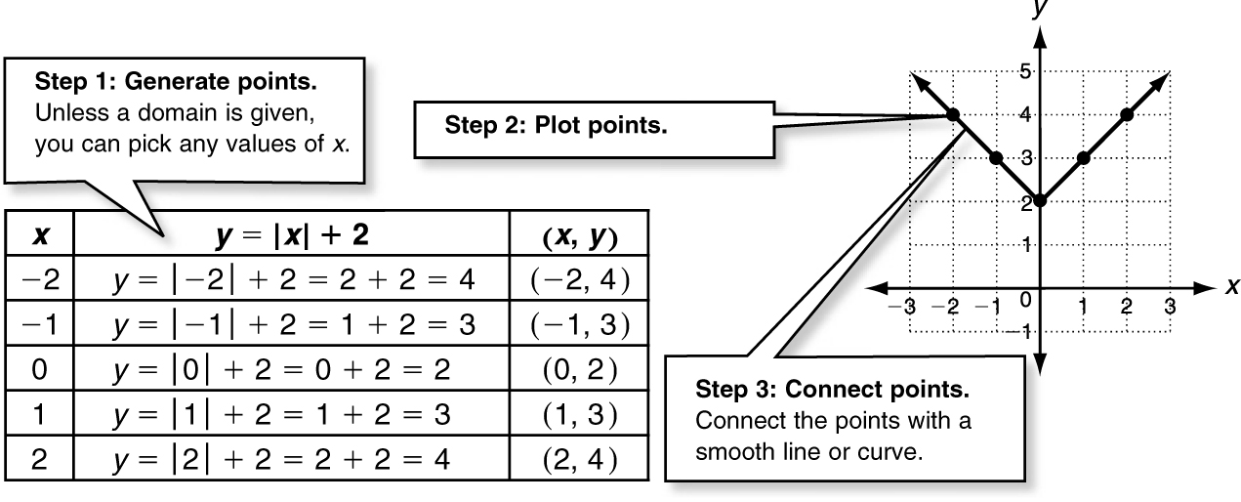
Remember that f(x) is function notation for y,
so rewrite the function as y = |x| + 2.

You can use the graph of a function to find points that
are generated by the function.
Use the graph of f(x) = −x² + 4 to find the value of f(x) when x = −3.
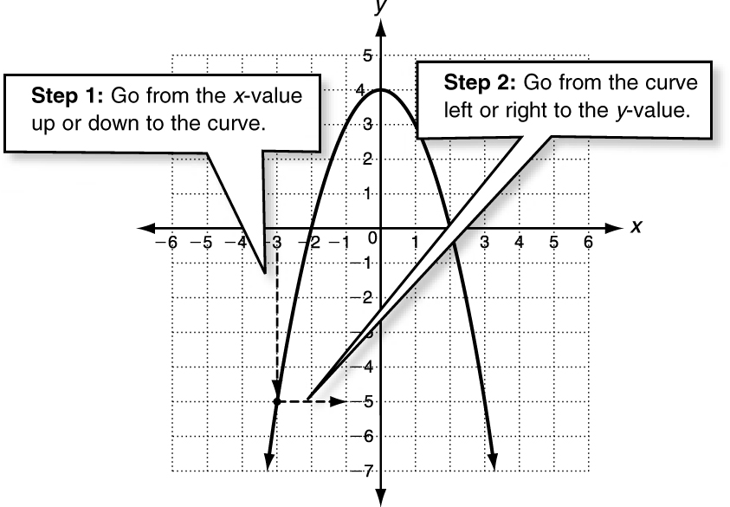
Remember that f(x) is function notation for y,
so you need to find y when x = −3.

Because (−3, −5) is a point on the
graph of the function,
f(x) = −5 when x = −3.

