Graphing Functions
Standard: SWABAT understand that the graph of an equation in two variables is the set of all its solutions. (MCC912.REI.10)

Name: ___________________________________ Mr. Murphey’s Coordinate Algebra Support
Date: 10/7/2013 Block: 1 4




Inbox Task –Solve each equation for y.

- $2x+ y =3$
- $-x+ 3y=-6$
- $4x - 2y = 8$

- Generate ordered pairs for $y =\frac{1}{2}x+1$ using x = -4, -2, 0, 2, and 4.

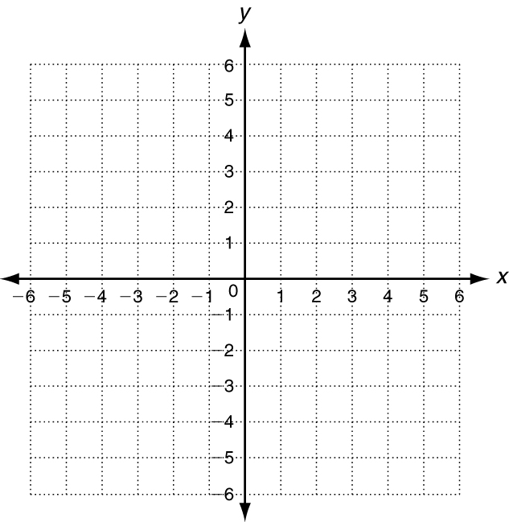
Graphing Functions
Graph the function for the given domain.
1. y = x + 2; D: {−2, −1, 0, 1, 2}
x | y = x + 2 | (x, y)
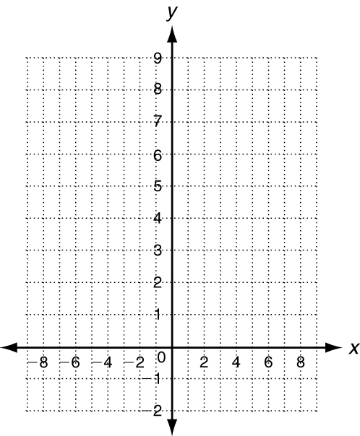
Graph the function. The domain is all real numbers.
2. y = x² ÷ 2
x | y = x² ÷ 2 | (x, y)
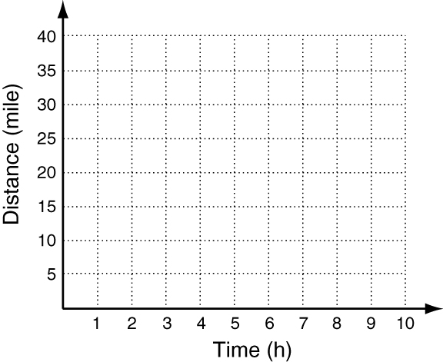
3. A Pacific salmon can swim at a maximum speed of 8 mi/h. The
function y = 8x describes how many miles y the fish swims in x hours.
Graph the function. Use the graph to estimate the number of miles the
fish swims in 3.5 hours.
x | y = 8x | (x, y)
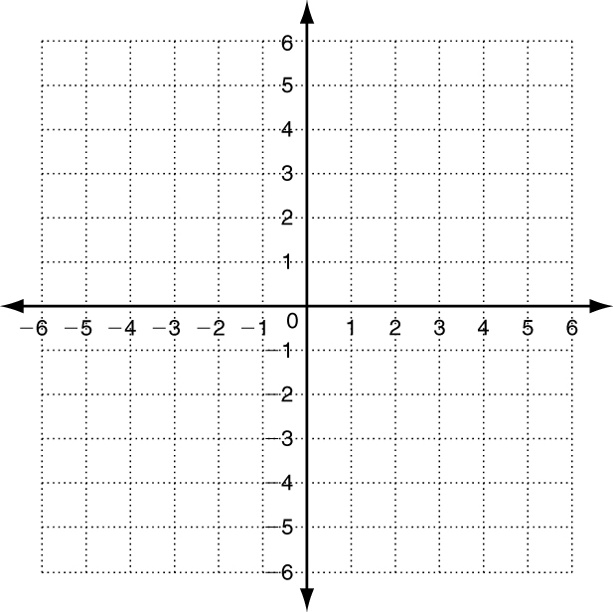
Graph the function for the given domain.
4. y = |x| −1; D: {−1, 0, 1, 2, 3}

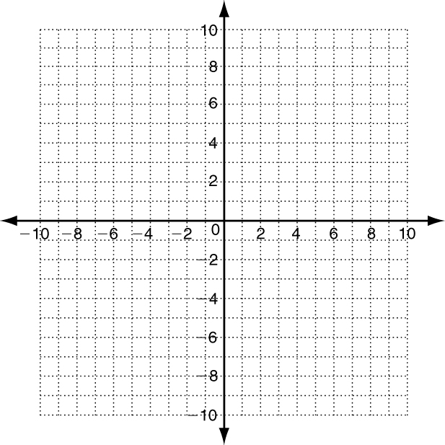
Graph the function.
5.f(x) = x² − 3

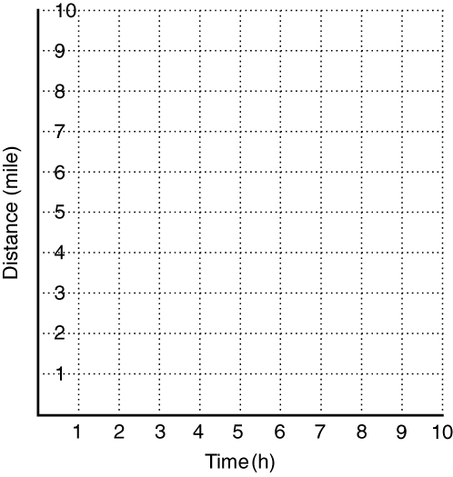

6. One of the slowest fish is the blenny
fish. The function y = 0.5x describes
how many miles y the fish swims in
x hours. Graph the function. Use the
graph to estimate the number of miles
the fish swims in 3.5 hours.

Graphing Transformations
A translation moves a point, figure, or function right, left, up, or down.
Horizontal Translation (right or left) | Vertical Translation (up or down)
The x-coordinate changes.  (x, y) → (x + h, y) | The y-coordinate changes.  (x, y) → (x, y + k)

Translate the function y = f (x) left 2 units.
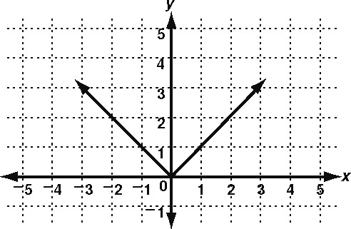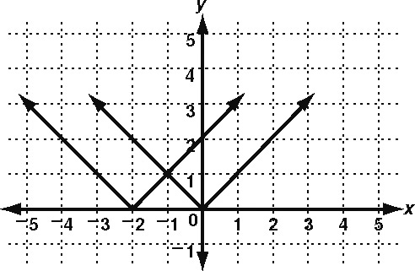
Move each point 2 units left. Connect the points. (x, y ) → (x − 2, y)
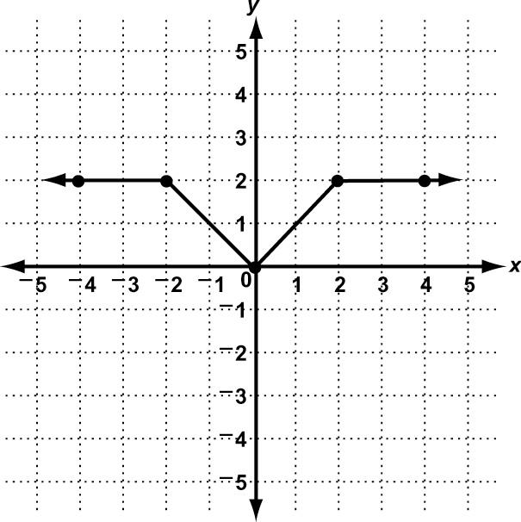
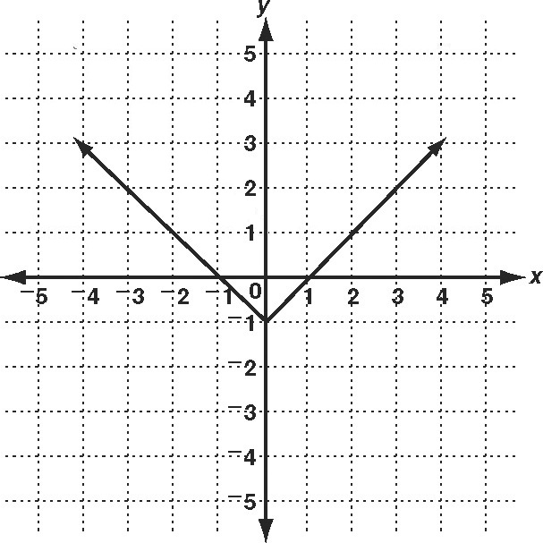
Perform each transformation of y = f (x).
1. translation up 2 units 2. Translation down 3 Units

