Exploring transformations
Standard: SWABAT Identify the effect on the graph of replacing f(x) by f(x) + k, k f(x), f(kx), and f(x + k) for specific values of k. (MCC912.F.BF.3)

Name: ___________________________________ Mr. Murphey’s Coordinate Algebra Support
Date: 10/9/2013 Block: 1 4


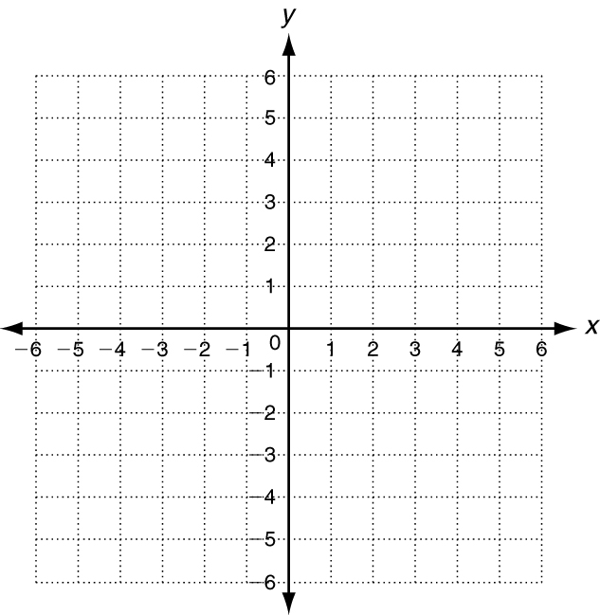


Inbox Task – Plot each point.
1. A (0, 0) 2. B (5, 0) 3. C (5, 0)
4. D (0, 5) 5. E (0, 5) 6. F (5, 5)

Graphing Transformations Perform each transformation of y = f (x).
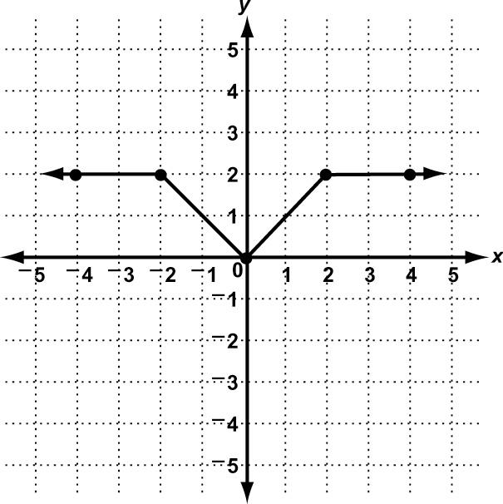
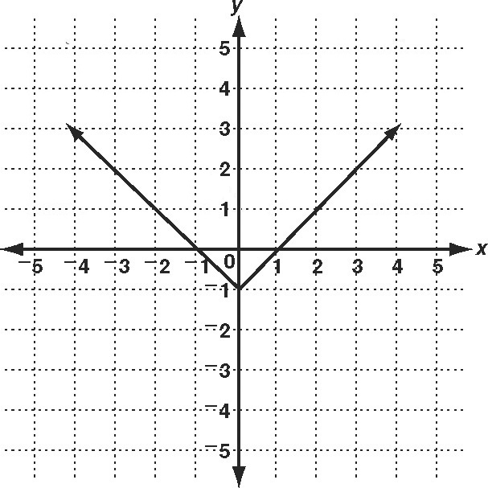
1. translation up 2 units 2. reflection across x-axis

3. horizontal stretch by a factor of 2 4. vertical compression by a factor of $\frac{1}{2}$
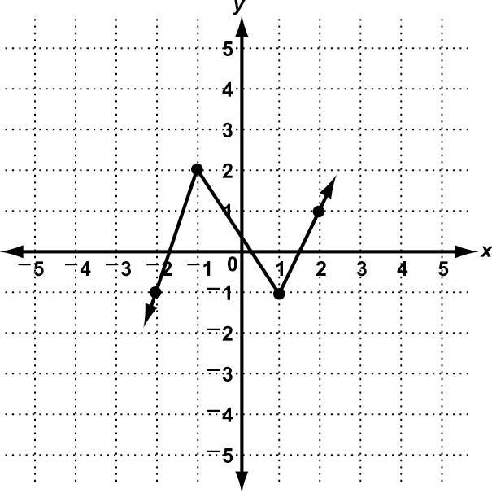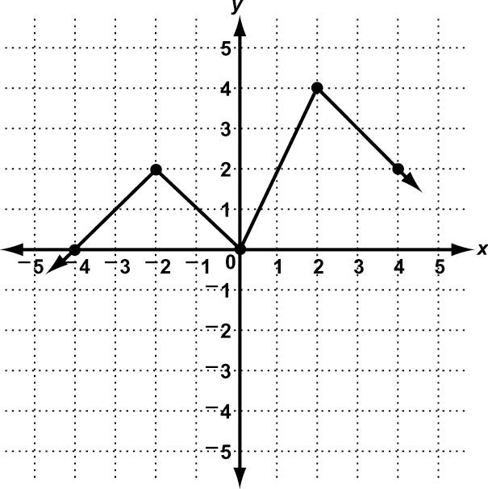

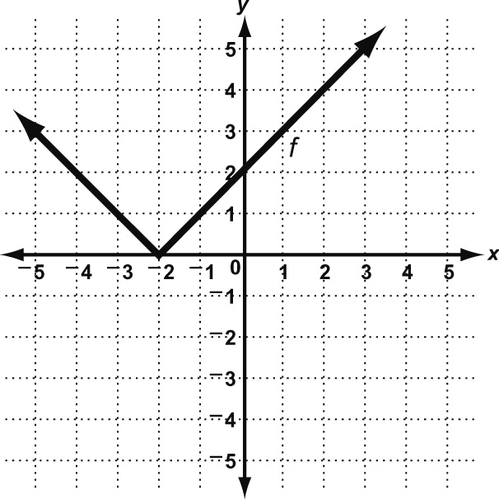
Exploring Transformations
Use the graph to perform each transformation described.
1. Plot point A at (4, 3). Translate point A left 5 units. Label this point B. Give the coordinates of point B. _______________
2. Plot point C at (1, 1). Translate point C right 2 units and down 3 units. Label this point D. Give the coordinates of point D._____________
3. Transform y = f(x) by translating it right 2 units. Label
the new function g. Compare the points that make up the 2 functions. Which coordinate changes, x or y? _____________
4. Transform y = f(x) by reflecting it across the x-axis. Label the new function h. Which coordinate changes, x or y? _____________

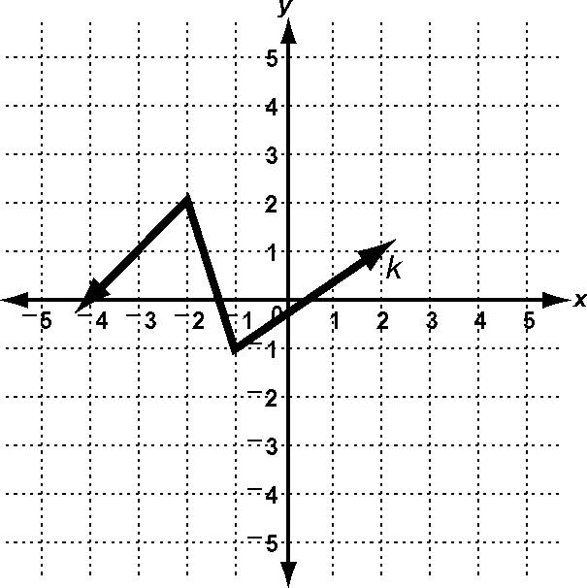
Use the graph to perform each transformation described.
5. Transform y = k(x) by compressing it horizontally by a factor of $\frac{1}{2}$. Label the new function m. Which coordinate is multiplied by $\frac{1}{2}$, x or y?

6. Transform y = k(x) by translating it down 3 units. Label the new function p. What happens to the y-coordinate in each new ordered pair?

7. Transform y = k(x) by stretching it vertically by a factor of 2. Label the new
function q. Which coordinate is multiplied by 2, x or y?

8. Describe how the coordinates of a function change when it is translated 2 units to the left and 4 units up.

9. Describe how the coordinates of a function change when you vertically compress a function by a factor of $\frac{2}{3}$.

Exploring Transformations
Perform the given translation on the point (2, 5) and give the coordinates of the translated point.
1. left 3 units 2. down 6 units 3. right 4 units, up 2 units

Use the table to perform each transformation of y = f (x). Use the same coordinate plane as the original.
4. translation left 1 unit, down 5 units
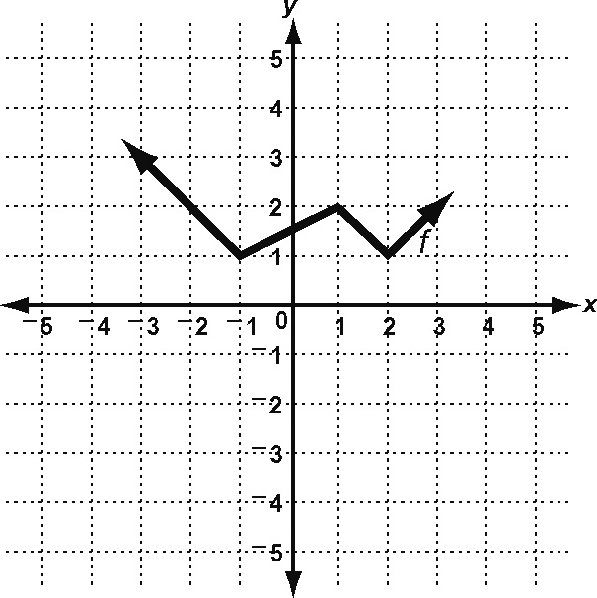
 | x | y
 | −3 | 3
 | −1 | 1
 | 1 | 2
 | 2 | 1
 | 3 | 2

5. vertical stretch factor of $\frac{3}{2}$ 6. horizontal compression factor of $\frac{1}{2}$ 7. reflection across x-axis
x | y
−3 | 3
−1 | 1
1 | 2
2 | 1
3 | 2

x | y
−3 | 3
−1 | 1
1 | 2
2 | 1
3 | 2

 | x | y
 | −3 | 3
 | −1 | 1
 | 1 | 2
 | 2 | 1
 | 3 | 2

Solve.
8. George has a goal for the number of computers he wants to sell each month for the next 6 months at his computer store. He draws a graph to show his projected profits for that period. Then he decides to discount the prices by 10%. How will this affect his profits? Identify the transformation to his graph and describe how to find the ordered pairs for the transformation.

