Arithmetic Sequences
An arithmetic sequence is a list of numbers (or terms) with a common difference between each number. After you find the common difference, you can use it to continue the sequence.
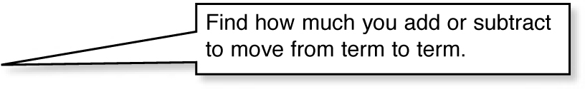
Determine whether each sequence is an arithmetic
sequence. If so, find the common difference and the next three terms.

1, 2, 4, 8, ...
+1 +2 +4
The difference between terms is not constant.
This sequence is not an arithmetic sequence.
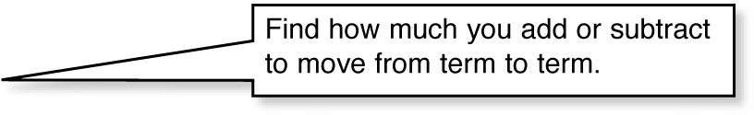
0, 6, 12, 18, ...
+6 +6 +6
The difference between terms is constant.
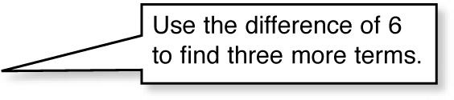
This sequence is an arithmetic sequence with a common difference of 6.
0, 6, 12, 18, 24, 30, 36
+6 +6 +6

You can use the first term and common difference of an arithmetic sequence to write a rule in this form: a_{n} = a₁ + (n − 1)d
After you write the rule, you can use it to find any term in the sequence.
common difference
term number
first term
any term
Find the 50th term of this arithmetic sequence:
5, 3.8, 2.6, 1.4, ...
The first term is 5.
−1.2 −1.2 −1.2
First, write the rule.
The common difference is −1.2.
a_{n} = a₁ + (n − 1)d Write the general form for the rule.
a_{n} = 5 + (n − 1)( −1.2) Substitute the first term and common difference.
Now, use the rule to find the 50th term.
a₅₀ = 5 + (50 − 1)( −1.2) Substitute the term number.
a₅₀ = 5 + (49)( −1.2) Simplify.
a₅₀ = 5 + (−58.8)
a₅₀ = −53.8
The 50th term is −53.8.
Arithmetic Sequences
An arithmetic sequence is a list of numbers (or terms) with a common difference between each number. After you find the common difference, you can use it to continue the sequence.
Determine whether each sequence is an arithmetic
sequence. If so, find the common difference and the next three terms.
1, 2, 4, 8, ...
+1 +2 +4
The difference between terms is not constant.
This sequence is not an arithmetic sequence.
0, 6, 12, 18, ...
+6 +6 +6
The difference between terms is constant.
This sequence is an arithmetic sequence with a common difference of 6.
0, 6, 12, 18, 24, 30, 36
+6 +6 +6

You can use the first term and common difference of an arithmetic sequence to write a rule in this form: a_{n} = a₁ + (n − 1)d
After you write the rule, you can use it to find any term in the sequence.
common difference
term number
first term
any term
Find the 50th term of this arithmetic sequence:
5, 3.8, 2.6, 1.4, ...
The first term is 5.
−1.2 −1.2 −1.2
First, write the rule.
The common difference is −1.2.
a_{n} = a₁ + (n − 1)d Write the general form for the rule.
a_{n} = 5 + (n − 1)( −1.2) Substitute the first term and common difference.
Now, use the rule to find the 50th term.
a₅₀ = 5 + (50 − 1)( −1.2) Substitute the term number.
a₅₀ = 5 + (49)( −1.2) Simplify.
a₅₀ = 5 + (−58.8)
a₅₀ = −53.8
The 50th term is −53.8.

