Arithmetic Sequences
Standard: SWABAT recognize that sequences are functions whose domain is a subset of the integers (MCC912.F.IF.3)

Name: ___________________________________ Mr. Murphey’s Coordinate Algebra Support
Date: 10/10/2013 Block: 1 4



Inbox Task –
Find the next 3 terms

- 12, 10, 8, 6

- 2. 5, 0, -5, -10, ...
a₁ =
d =
a₂₆=
3. 35th tem: 59, 56, 53, 50

Arithmetic Sequences
For the following sequences, find a₁ and d and state the formula for the general term.
5. -2, -5, -8, -11, … a₁=_________ d=____________ Formula:

6. 3, 10, 17, 24, … a₁=_________ d=____________ Formula:

Representation | Arithmetic? | Common Difference | Explicit Formula | Given Term
7. 2, 8, 14, 20, …

8. 17, 12, 7, 2, …

Graphing Functions
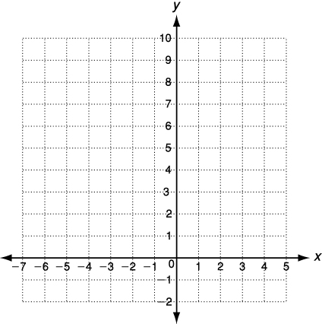
Graph the function for the given domain
1. y = (x - 2)²
x | y = (x + 2)² | (x, y)
-4
-3
-2
-1
0

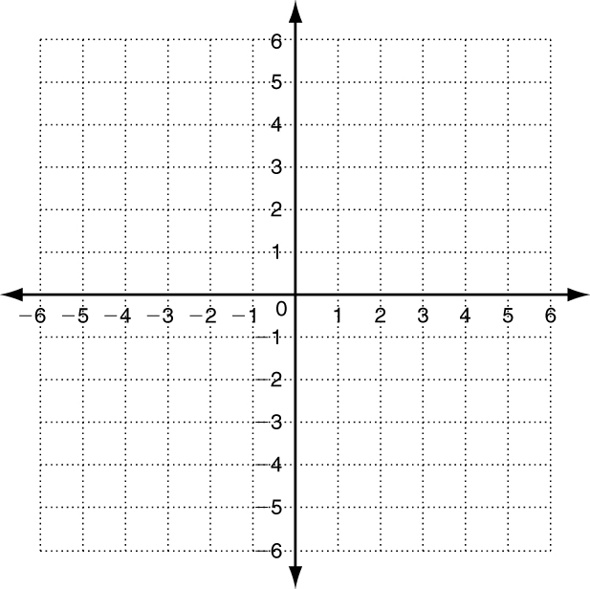
2. y = -|x| + 4; D: {-1, 0, 1, 2, 3, 4}

Graphing Transformations Perform each transformation of y = f(x).
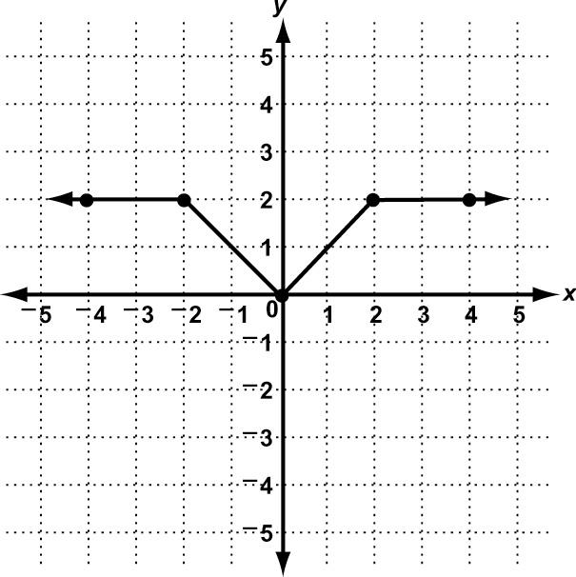
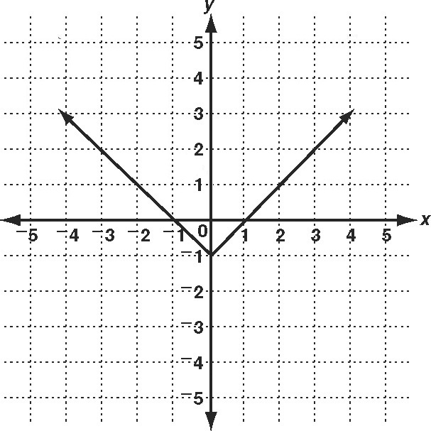
1. reflection across x-axis 2. translation down 2 units and right 1 unit

3. horizontal compression by a factor of $\frac{1}{2}$ 4. vertical stretch by a factor of $\frac{3}{2}$
